pe Official Publication of ALOA—An International Association of Security Professionals

**February 2005**

**[www.aloa.org](http://www.aloa.org)**

Specialty Locks/

Applications

**Holu** do Electromagnetic  
Locks keeps coins and  
nuclear reactors cool?  
Flip to Page 10 to find out!

**PLUS!**

Mul-T-Lock Weighs in on Bump Keys, Daue Thielen Gets Religion,

Greg Perry Tackles a Pocket Door and Cabinet Locks, New Products, Equipment Leasing Options, and More!

Breck H. Camp CML PO Box 47070 Atlanta GA 30362-0070

liillilliiiii!liillimiillli..lli.i!mllliiilm!llm.ilill



OUR STAND

WE’RE IN BUSINESS TO HELP YOU

**REDUCE DOWNTIME.**

Commercial vehicle insurance designed to help you get back on the road.

When your vehicle is out of business, so are you. That's why Allstate provides fast and fair claim service. Your local Allstate agent offers

commercial vehicle insurance as well as other insurance products designed to help keep your business in the race. Are you in Good Hands®?

1-800-859-0247

**CALL NOW TO LOCATE YOUR  
NEARBY ALLSTATE AGENT.**



**Subject to availability and qualifications. Allstate Insurance Company and Allstate Indemnity Company, Northbrook, 1L. Allstate County Mutual Insurance Company, Irving, TX. Allstate New Jersey Insurance Company, Bridgewater, NJ.The "Cupped Hands" jogo is a registered service mark and "Our Stand" is a service mark of Allstate Insurance Company. © 2005 Allstate Insurance Company, Northbrook, IL.**

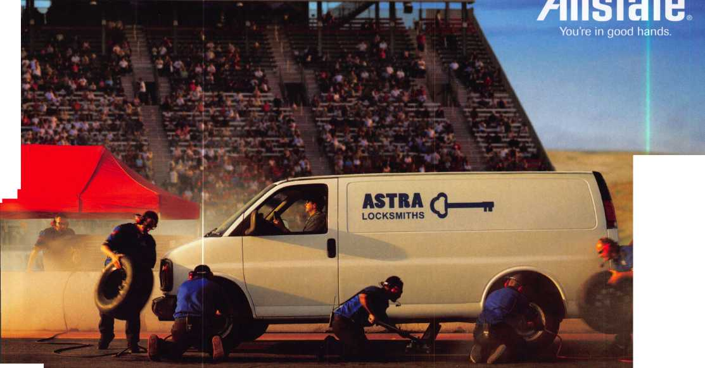

!>

W'eY Mac, keeping up with the latest the industry has to offer has never  
been more important for us safe technicians. Let me tell ya, you gotta stay  
aware of what today's top safe distributors and manufacturers are putting out  
there. It's crucial to making a humdinger of a purchasing decision, buddy.  
And another thing, time is of the essence when it comes to education. New  
things pop up every day, Daddy-O, and that makes top-notch safe classes  
as good as gold. The only chance to get world-class education and meet  
with the industry's top distributors and manufacturers is the SAFETECH  
Convention and Trade Show. Boy, is it swell! SAFETECH 2005 offers you  
a chance to meet with potential customers and bolster business in ways  
you never thought possible. Discover the safes of tomorrow! Gee whiz,  
jump and jive your way into Safetech 2005, and you'll be part of our  
knock 'em, sock 'em show of all shows!!

The 0afc and Vault Technicians associataion  
Conoention and Trade j^hom

March 6—12, 200S

*Hyatt Regency, Lexinyten KY*

*Safetech Oisits Seautifuf Lexinqton, Kentuckul*

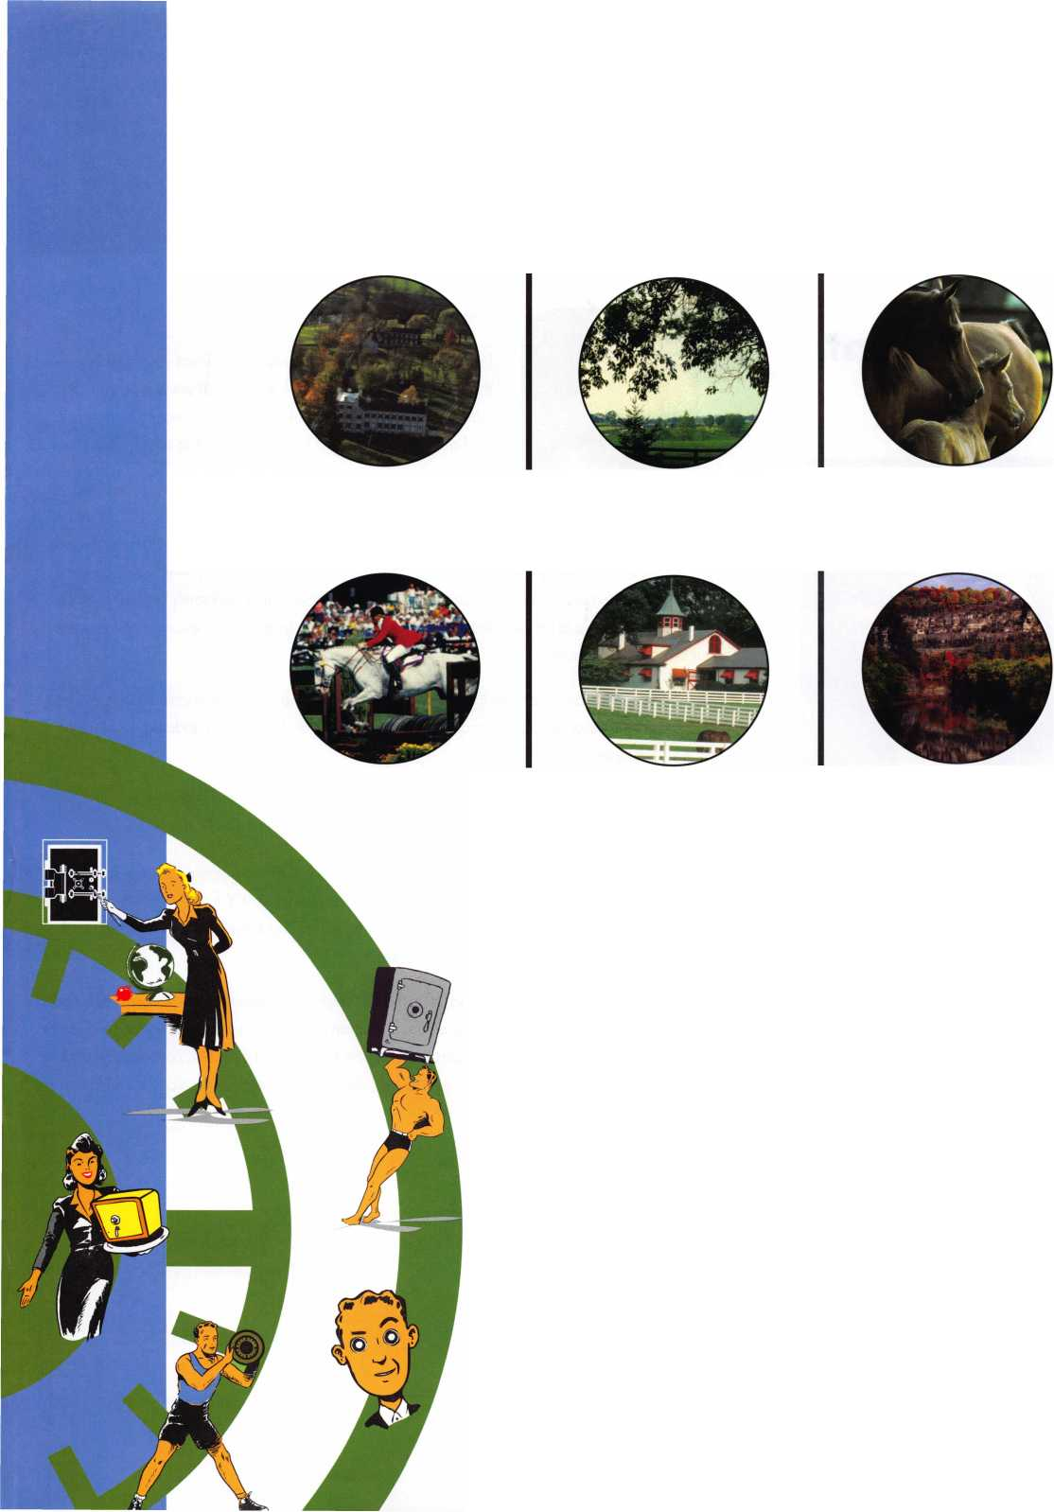

presidential

viewpoint

Important

Notice

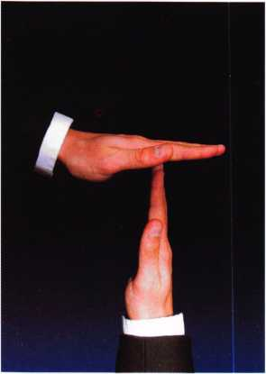

The Headquarters of the Associated Locksmiths of America will be relo­cating to a new office building some time early this year. During the time of the move, some ALOA services will be temporarily unavailable. These services include, but ar not limited to, the following:

* Incoming Calls
* Database Inquiries
* Staff Support for the Web and all other departments

It is suggested that all ALOA and SAVTA members make note of this change. (This ad will be ammended when the actual move dates are confirmed.)

The ALOA staff is looking forward to the new location and the opportunity to provide you with improved mem­ber services during the New Year.

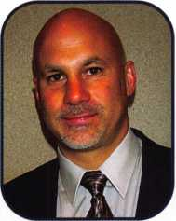

One of the biggest advantages for members is to be listed in  
the improved locksmith search areas. The areas are broken  
down by Manufacturer's Locksmith search... which can be used

by manufacturers to verify membership, the All-Access Locksmith search... which can be used  
by possible customers with internet access and, the Members-Only, locksmith search. Remem-  
ber, you must sign up to be included in the search and take advantage of the calls that will come  
your way. So, do it now!

Dear Members,

I would like to take this opportunity to direct your attention to  
the new and improved ALOA Website at [www.aloa.org](http://www.aloa.org). The  
staff at ALOA has done an excellent job in creating a new look  
and greater features and capabilities for the site.

Some other important changes to the website to the website include a calendar that was  
redesigned for functionality, better access to PRP information and sittings, an updated ALOA store,  
and new message boards.

The message board is the best place to direct questions to the directors of the association, as  
we will be monitoring them regularly.

Following the holiday layoff, the events and activities of the industry are starting to pick up again.  
One show not to miss will be the SAVTA Convention in Lexington, KY from March 6-12. Sign  
up now to visit the safe lock capital of the world, receive "world class" training and help Lock-  
masters celebrate 50 years of service to the industry.

Our industry has lost several good people in the last year and, I regret that one more name has  
been added to the list. Lou Gildenburg, a true gentleman and the current president of the Greater  
Philadelphia Locksmiths Association, passed away on December 1 8, 2004. Lou will be deeply  
missed in the Philadelphia area. Vice-president, Bob Schuetrumpf, will step up and do an  
admirable job for this excellent association.

Sincerely,

William Young CML,CPS

President

Keynotes • February 2005



**RLOR 2005**

**The RLOR**

**Conuention**

**and Security Expo July 17-24, 2005**

Baby, you know you want to yo!

Sweet Home Chicago

SWEET

Get Ready for RLOR 2005,

a powerful resource to explore innouation and form industry alliances. TTiis year we’ue thought of euerythiny from an exciting location, comfort­able accommodations and a conuention center that is equipped to handle your euery need.

Located just minutes from downtown  
Chicago, Rosemont, Illinois is the  
perfect “business uillage”, designed specifically  
to make your stay conuenient, comfortable  
and aboue all, successful!

The 49th Rnnual RLOR Conuention and Security Expo  
offers top-notch classes, workshops, networking  
opportunities and cutting-edge technology.

Rnd don’t miss out on the fine dining and enter-  
tainment options that Chicago has to offer. Shop  
at the world-famous Magnificent Mile. Eat at  
Morton’s of Chicago or Hairy Caray’s Italian  
Restaurant. Uisit the Nauy Pier or catch a ball  
game. The options are endless when you register  
today for the single-most important euentin  
the locksmithing industry.

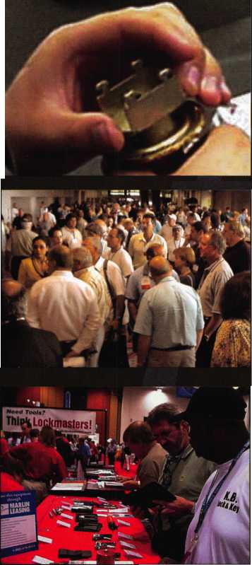

f

e

a

t

u

res

SPECIALTY LOCKS/APPLICATIONS 2005



Specialty Lock Applications

How do you use your locks? In this article, we explore two unique applications involving a nuclear reactor and some very cool cows.

**13**

**14**

Mult-T-Lock: Always Ahead of the Game

Find out how Mul-T-Lock has responded to security threats involving new methods of cylinder manipulation. This article features graphics and a discussion of locks carefully con­structed to defend against picking, drilling and bumping.

The Agnus Dei Safe

Read this in-depth study of a unique safe used in the Catholic Church for centuries. This container was consid­ered to be "very old and very special". We consider it to be a work of art.

by Dave Thielen, CML

**17**

Important Information for Locksmiths from the U.S. Patriot Act



**24**

There are very specific requirements regarding security applications and the Department of Defense. Be prepared for anything with this excerpt from the U.S. Patriot Act.

Cabinet Lock Choices

Keyed cabinet locks come in a wide variety of styles, shapes and keying possibilities. New installations are not difficult, but replacing existing locks can be challenging.

by Greg Perry, CML, CPS

Pocket Door Solution

A detailed study of the Von Morris 9200 series pocket door. This is an expensive solution, but compared to a new door and frame, may be the best idea for your bottom line.

by Greg Perry, CML, CPS

**Departments**

**30**

**34**

New Products from Master Lock

As with most companies, the only way to increase your business is to develop new products. Let Master Lock show you how their new products can increase your sales potential.

by Roxanne Piagentini and Billy B. Edwards, Jr.

Why Leasing Pays

in todays increasingly competitive marketplace, more and more companies are integrating leasing into their sales process. It is becomming easier to sell additional CCTVs and DVRs by simply offering your customers a financing alternative.

by Joseph Finelli

**AD INDEX**

|  |  |  |
| --- | --- | --- |
| Allstate | Inside Front Cover | |
| Sodium Halogen |  | 7 |
| Keedex |  | 19 |
| Professional Business Products | | 21 |
| T-Core |  | 23 |
| Lockmasters |  | 25 |
| Hinge Doctor |  | 29 |
| Master Lock |  | 33 |
| MLANJ |  | 41 |
| Buyer's Marketplace |  | 42 |
| CCL | Inside Back Cover | |
| Hickok | Back Cover | |

Presidential Viewpoint 2

Execu ive... Applicants

5

6

Calendar 8

Core 9

Classified 36

Associate Members 38

Legislative 40

Visit our website at

[www.aloa.org](http://www.aloa.org)

executive

Volume 51, Issue 2

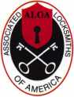

Additional contact information for the ALOA Board and most Keynotes authors is  
available through "Locksmith Search'" on the ALOA Web site- [www.aloa.org](http://www.aloa.org) or by  
contacting the ALOA office at 3003 Live Oak Street; Dallas, TX 75204; (800)532-2562;  
FAX (214)827-1810; e-mail [aloa@aloa.org](mailto:aloa@aloa.org).

|  |  |
| --- | --- |
| Publications Manager  Betty Henderson | [betty@aloa.org](mailto:betty@aloa.org) |
| Technical Editor  David Lowell, CML, CMST | [david@aloa.org](mailto:david@aloa.org) |
| Editorial Advisor  John Cannon, CML | jcannonl @cox.net |
| Advertising Sales  Kim Hammond | voice: 817-645-6778 |
| Executive Director  Charles W. Gibson, Jr., CAE . | Fax: 817-645-7599 e-mail: [adsales@aloa.org](mailto:adsales@aloa.org)  [charlie@aloa.org](mailto:charlie@aloa.org) |

Associate Executive Director

David Lowell, CML, CMST [david@aloa.org](mailto:david@aloa.org)

Convention & Meetings Manager

Jo Anne Mims [joanne@aloa.org](mailto:joanne@aloa.org)

Operations/Membership Manager

Mary May [mary@aloa.org](mailto:mary@aloa.org)

Government Relations Manager

Paul Kanitra [paul@aloa.org](mailto:paul@aloa.org)

IT Operations Manager

Greg Jackson [greg@aloa.org](mailto:greg@aloa.org)

Comptroller Kathy J. Romo

Membership Coordinator Shelly Jett

Convention & Meetings Assistant Karen Lyons  
PRP/Education Coordinator Hope Rodriguez

Accounting Coordinator

Mail Room Coordinator Kevin Wesley

Publications Coordinator Bryan Dease

Executive Assistant Sue Langford

Receptionist Wendy Wilder

Contributors

Jerome Andrews, CML  
Paul Chandler, CRL  
Claire Cohen, CML  
Brian Costley, CML, CMST  
Eric Costley, CRL

Ray D'Adamo, CML Billy Edwards, CML Dan Graffeo, CRL,CMST Jim Hancock, CPL Jeff Nunberg, CML, CMST

Randy Simpson, CML, CPP Robert Stafford, CML Dave Thielen, CML Greg Perry, CML,CPS

Tom Seroogy

Charles Stephenson, CPS

Dennis Watanabe, CML, CMST

Mission Statement: The Associated Locksmiths of America, Inc. is dedicated to enhancing the professionalism, education and ethics among  
locksmiths and those in related sectors of the physical security industry. With approximately 10,000 members in the United States, Canada and the  
freeworld, ALOA is poised to help members obtain the knowledge, the strength, and the confidence to perform their role in the physical security field  
with pride and dignity. But it is only through active involvement and participation that ALOA can fully achieve its potential—and can help members to  
achieve theirs.

Policies: Keynotes® is the official publication of the Associated Locksmiths of America, Inc. (ALOA). Keynotes® acts as a moderator without approving,  
disapproving, or guaranteeing the validity or accuracy of any data, claim, or opinion appearing under a byline or obtained or quoted from an acknowl-  
edged source. The opinions expressed by the authors do not necessarily reflect the official views of ALOA. Also, appearance of advertisements and  
new products or service information does not constitute an endorsement of products or services featured by the Association. The Association does not  
accept responsibility for the inaccuracy of any data, claim, or opinion appearing in this publication, due to typographical errors on the part of the  
authors, Association staff or its agents.

Editor's Note: This publication is designed to provide accurate and authoritative information in regard to the subject matter covered. It is provided  
and disseminated with the understanding that the publisher is not engaged in rendering legal or other professional services. If legal advice and other  
expert assistance is required, the services of a competent professional should be sought.

Authors' Payment: Payment for eligible submissions to Keynotes will be based on the following criteria: topic, time spent and past contributions. Authors who  
regularly submit to Keynotes® are generally paid a higher rate. The latter is especially true of authors who write to fit specific editorial needs and submit said copy  
by Keynotes® deadlines. As a general guideline: Average payment for a 750 word, business or 'light' technical article would be $200. Payment for a 1500 word  
article involving significantly higher time and research efforts would be $400.

Payment will not be offered for articles submitted by ALOA employees or members of the ALOA Board of Directors (unless material is of a technical  
nature), nor for articles submitted by a company that promote that company's products or services. ALOA reserves the right not to pay for articles sub-  
mitted by an individual(s) that promote a particular company's products or services.

Disclaimer: The Associated Locksmiths of America, Inc., (ALOA), reserves the right to refuse any article for any reason. Additionally, ALOA reserves  
the right to edit, amend or modify any article submitted for publication in order to preserve technical accuracy, clarity, fairness or grammatical cor-  
rectness. ALOA will make the best efforts to notify the author of any changes. The extent of ALOA's liability for any article or information contained  
therein will be a notice of correction or retraction in the next possible issue.

Keynotes® (ISSN 0277 0792) is published monthly except for the combined June/July issue by The Associated Locksmiths of America, Inc.,  
3003 Live Oak St., Dallas, TX 75204-6186. Telephone: (214) 827-1701; FAX (214) 827-1810; e-mail [aloa@aloa.org](mailto:aloa@aloa.org). Subscription rates for  
members—$15.00 per year. Periodical class postage paid at Dallas, Texas. POSTMASTER: Send address changes to: Keynotes, 3003 Live Oak St.,  
Dallas, TX 75204-6186. © Copyright 2003, All rights reserved. No part of the contents may be reproduced or reprinted in any form without prior  
written permission of the publisher.

President

William L. Young, CML  
(610)647-5042  
[president@aloa.org](mailto:president@aloa.org)

Secretary

John Soderland, CML, CMST  
(414) 327-5625  
[secretary@aloa.org](mailto:secretary@aloa.org)

Directors/ Northeast

Robert E. Mock

(856) 863-0710  
nedi recfor@aloa. org

Peter Sarailian, CRL  
(973)890-9797  
[nedirector@aloa.org](mailto:nedirector@aloa.org)

Vernon Kelley, CPL

(609) 771-3126  
[nedirector@aloa.org](mailto:nedirector@aloa.org)

Directors, Southeast

Tom Gillingham, Jr., CML, CPS  
(615)264-0747  
[sedirector@aloa.org](mailto:sedirector@aloa.org)

Ken Kupferman, CPL

(813)961-5784

[sedirector@aloa.org](mailto:sedirector@aloa.org)

Director, North Central

Mark E. Blum, CML, CPS  
(517) 482-5809  
[ncdirector@aloa.org](mailto:ncdirector@aloa.org)

Director, South Central

CD Lipscomb, CML, CPS  
(903)874-3522  
[scdirector@aloa.org](mailto:scdirector@aloa.org)

Directors, Southwest

Gordon R. Racine, CML  
(719) 384-4707  
[swdirector@aloa.org](mailto:swdirector@aloa.org)

Julie McCluney, CRL  
(714) 636-5652  
swdirector@aloa .org

Director, Northwest

Jim Jeffries, CPS  
(208)743-1 101

nwdirector@aloa. org

Director, European

Hans Mejlshede, CML  
(453)539-3939  
[eurdirector@aloa.org](mailto:eurdirector@aloa.org)

Director, Asian

Joe J. Lee, CRL  
(215)289-2404  
[asiandirector@aloa.org](mailto:asiandirector@aloa.org)

Director, Associate

Paul M. Justen  
(800)333-6953  
[asdirector@aloa.org](mailto:asdirector@aloa.org)

Trustees

[trustees@aloa.org](mailto:trustees@aloa.org)

Randy Simpson, CML  
(281)240-5959

John J. Greenan, CML, CPS  
(773) 486.2030

Past Presidents

2001-2003 Randy Simpson, CML  
1999-2001 John Greenan, CML, CPS  
1997-1999 Dallas C. Brooks  
1995-1997 David Lowell, CML, CMST  
1993-1995 Breck Camp, CML  
1991-1993 Henry Printz, CML  
1989-1991 Evelyn Wersonick, CML, CPS  
1987 1989 Leonard Passarello, CPL  
1985-1987 Joe Jackman, CML  
1983-1985 Stanley Haney, CPL  
1981-1983 Louis LaGreco, CPL  
1979-1981 John Kerr, RL  
1977-1979 Clifford Cox, CML  
1974-1977 Charles Hetherington  
1972-1974 Gene Laughridge  
197G1972 William Dutcher, RL  
1968-1970 Constant Maffey, RL  
1966-1968 Harold Edelstein, RL  
1964-1966 William Meacham  
1962-1964 Robert Rackliffe, CPL  
196a1962 Edwin Toepfer, RL  
1956-1960 Ernest Johannesen



Keynotes • February, 2005

AL

GA

applicants

for membership



# 41

Auburn University

Glenn E. Welch

Sponsor: Marian E. Sagar

Hartselle

Gordon L. Slocum

Pelham

TerryMoore

AZ

Huachuca City

Dale A. Cook

Sponsor: DeForest S. Lewis Jr, CRL Mesa

Nader W. Zebian

Sponsor: John A. Ilk CRL, CPS

Jeffrey D. Howard

Sierra Vista

Michael L Beardsworth

Tucson

Thomas E. Sly CML

Sponsor: Colin L Smith Jr

Roger A. Burns

Sponsor: DannySilver

CO

Manitou Springs

KeithGillmer

Steamboat Springs

MatthewSpady

Sponsor: Dwight R. Spady

FL

Miami

MisaelPena

Sponsor: Richard A. Dragin CML

ArnaldoMercado

Sponsor: Richard A. Dragin CML

Athens

ThomasChism

Sponsor: Anthony FrankMcDade CRL Carrollton

Dennis Loworn

Covington

Gary L Young

Sponsor: John C. Elliott Jr, CML, CPS Tifton

JeffStatham

Sponsor: James D. Eaton

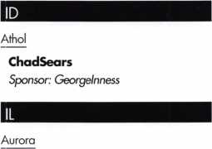

**Joe** Lehnert

Sponsor: Michael R. Lehnert CPL Bolingbrook

Robert J. Akin III

Sponsor: Robert J. Akin Jr

Chicago

Andrew B. Connolly

Sponsor: William T. Beranek

Collinsville

JonathonBean

Sponsor: Donald E. Bean CRL

Hoffman Estates

MichaelFallon Jr

Sponsor: MichaelFallon

Rolling Meadows

David B. Ochal

Sandwich

DanLaSourd

Sponsor: Michael R. Lehnert CPL

IN

Columbus

Timothy E. Hammock

Sponsor: Kenneth L Hammock

Indianapolis

Robert W. Robinson

Sponsor: JimWilliams CRL

Nashville

Shawn D. Fosnight

Sponsor: Kenneth L. Hammack

KS

Spring Hill

Brian Ross

Sponsor: JCaseyCamper CML, CPS



Lexington

Elizabeth K. Cox

Sponsor: TimAbner

PhilipSutherland

Sponsor: TimAbner

SusanAbner

Sponsor: TimAbner

AndrewBierlein

Sponsor: TimAbner

LA

Lafayette

Luke B. Brignac

Sponsor: Darryl R. Hoosier

New Orleans

JamesCrawford Jr

Sponsor: Rene C. Comeaux CRL

MD

Chevy Chase

Marcel F. Smith

Sponsor: Michael C. Olson CRL

Gaithersburg

ToddSchuch

Sponsor: Carl Rollison

Ml

Detroit

James P. Fyn Jr

Sponsor: Reginald W. Moxley CPL

Petoskey

Jared Urman

MN

Golden Valley

KevinPotter

Sponsor: Mark D. Johnson CPL

MT

Helena

Kip R. Burdick

Sponsor: Daniel W. Burdick

NC

Charlotte

Neil Pobuda

Sponsor: Kevin D. Kirby CRL

Woodleaf

MichaelMcDaniel

Sponsor: Joe M. Estridge CML, CPS

ND

Jamestown

Chad Nelson

NE

Lincoln

Ryan Andersen

Sponsor: John L. Firestine

NH

Intervale

Paul M. Robert

Sponsor: Alain H. Robert CRL

These applicants are scheduled for clearance as members of ALOA. The names are published for member review and comment within 30 days of this Keynotes issue date,  
respectively, to ensure applicants meet standards of ALOA's Code of Ethics. Protests, if any, should be addressed to the Membership Department and must be signed. Active  
Membership applicants (a) have worked in the industry two or more years. Allied Membership (AL) applicants are not locksmiths, but work in a security-related field.

Apprentice Membership (AP) applicants have worked in the industry less than two years.

**6**

Keynotes • February 2005

Milford

NY

TX

England

Timothy R. Goguen

Sponsor: Jonathan T. Bossie

Nashua

Steven H. Davis

Sponsor: Jonathan T. Bossie

Pelham

BrianEmond

Sponsor: SteveJoyal

Pembroke

Michael L Crocker

Sponsor: Jonathan T. Bossie

NJ

N utley

Daniel Corino

Sponsor: Glen I. Davies CPL

Pompton Plains

Paul J. Maka

Wayne

David M. Schwartz

Sponsor: Glen I. Davies CPL

Amityville

KrystalCaroleo

Sponsor: Richard R. Peterkin CPL

Plain view

MathewSolomon

Sponsor: Mitchell D. Horowitz

OH

Plain City

Robert E. Poholsky

Sponsor: Timothy J. Moore CRL



Knoxville

GregWalters

Sponsor: John E. Simpson

Shelbyville

BarryWestbrook Sr

Tullahoma

Joseph A. Jennings II

Sponsor: Chris W. Cyree CPL

Corsicana

DavidPage

Sponsor: Clifford D. Lipscomb CML, CPS

VA

Falls Church

BenjaminWoodward

Wl

Glen wood City

Sandra J. Grant

Sponsor: Daniel J. Grant

Onalaska

Gary L Blanchard

Sponsor: Kenneth W. Briggs

Oregon

Edwin H. Krueger

Canada

BC - Creston

StevePoznikoff

Solihull, West Midi

JasonRainey

Sponsor: KenDale

Lincoln

David Barber

Sponsor: KenDale

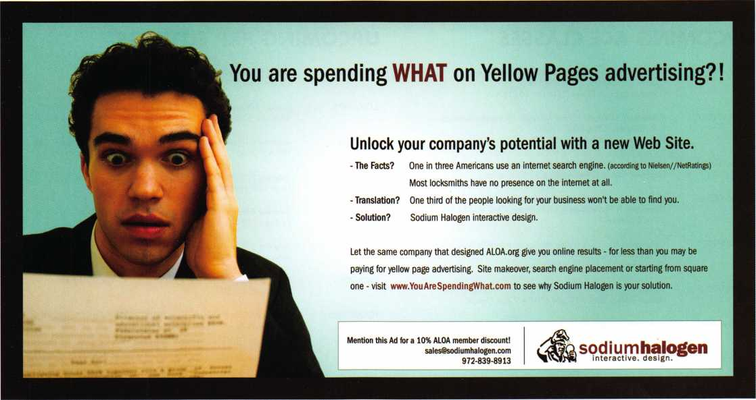

Keynotes • February 2005

p c o m

events

u

i n g

|  |  |
| --- | --- |
| 5 West Coast Lock Collectors  Show  El Segundo, CA  310-395-4407 | 9 New York Master Locksmiths' Assoc.  Monthly Meeting  NYC/Long Island Area  718 274-6930 |
| 1 3-6 MLANJ 2005 Convention & Security Expo | 7-12 SAFETECH 2005 15-20 Texas Locksmiths Association  Lexington, KY Annual Convention and  Trade Show  210-649-2166 |
|  |  |

7-9 California Locksmiths AssocL

Trade Show & Educational  
Program

UPCOMING ACE CLASSES UPCOMING PRP SITTINGS

|  |  |  |  |
| --- | --- | --- | --- |
| 2/12/2005 | Detroit, Michigan • Locksmiths Security Association  Robert C. Nobel, CPL 810-385-9329  Complete Door and Door Closers w/L-05 PRP | 2/26/2005  2/27/2005 | Saturday • 9:00am Roseville, Ml • Locksmith Security Assn  Robert Noble, CPL 810-385-9329  Sunday 9:00am • Maplewood, MN • Minnesota Chapter |
| 2/19-20/2005 | Kalamazoo, Michigan • West Michigan Locksmiths Association  R. Paul Bentley, CPL 269-327-8400 |  | Dana Lee, CML 952-887-1199 |
| 2/25-27/2005 | Motorcycle Locksmithing w/L-22 PRP  Minneapolis, Minnesota • Minnesota Chapter of ALOA • | 3/5/2005 | Saturday 8:00am • Somerset, NJ • MLANJ 200 • Bill Timmann, CML 908-859-3135 |
| 3/3-6/2005 | Dana Lee, CML 612-968-4500 • 5 ACE Classes  Somerset, New Jersey • Master Locksmiths of New Jersey Annual | 3/12/2005 | Saturday 8:00am • Lexington, KY • SAFETECH 2005  Hope Rodriguez 800-532-2562x30 |
|  | Convention & Trade Show • Bill Timmann, CML, 908-839-3135  21 ACE Classes | 3/19/2005 | Saturday 8:00am • Corpus Christi, TX • TLA Convention  Ed Stites 979-240-9083 |
| 3/19-20/2005 | Kalamazoo, Michigan • West Michigan Locksmiths Association  R. Paul Bentley, CPL 269-327-8400  Combination Lock Manipulation (2 days) | 4/30/2005  7/22/2005 | Saturday 6:00pm • Denver, CO • Central & Southern Colorado Locksmiths Assn • Gordon Racine, CML 719-384-4707  Friday 6:00pm • Rosemont, IL ALOA 2005 • Hope Rodriguez |
| 4/28-30/2005 | Denver, CO • Central & Southern Colorado Locksmiths Assn  Gordon Racine, CML 719-384-4707 • 9 Ace Classes | 10/09/2005 | 800-532-2562x30  Sunday 9:00am • Orlando, FL • SERLAC 2005 • James Barnhardt, RL |
| 7/17-24/2005 | Rosemont(Chicago), Illinois • ALOA 49th Annual Convention & Security Expo • David Lowell, CML,CMST 800-532-2562 xl 8  70 full day classes • 35 half day classes & evening seminars |  | 813-689-5979 |

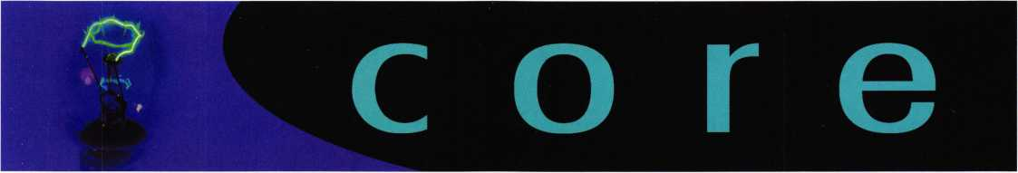

In Memory

Lou Gildenburg, CPL, ALOA member, passed away on December 18, 2004, following a battle with cancer. Lou was the current president of the Greater Philadelphia Locksmiths Association, having been elected in October 2003. Lou was a 30+ year member of GPLA and he also served the associa­tion as director, secretary, and vice-president. He was the owner and founder of DMD Superkey Locksmith, Inc. in Cherry Hill, NJ and ran that busi­ness for 35 years. Lou was also a veteran of the US Navy. He will be dearly missed in the Philadelphia region.

In Memory

Life member, John Dziuba, RL -Buffalo, NY, recently passed on due to heart failure. John Joined ALOA in 1956 and was one of the original charter mem­bers of the organization. Mr. Dziuba was on the committee that selected ALOA's present headquar­ters location. He will be missed.

In Memory

Nicholas A. Monaco, CRL. Member since 1978.

Certifications

CML'S

Fuller, Mark W.

CPL'S

Brown, III Stewart K.  
McMenimon, Barry L.  
Costley, Eric A.

Fuller, Hank P.

Smith, Ronald, R.  
Eatmon, Thomas L.  
Rink, Lee W.

CRL'S

Marshall, Robert A. Sanford, David F. Varner, Kenneth E. Sr. Baxter, James E. Whetsell, Stan M. Beasley, Marvin Casper, Richard F. Gravitt, Russell M.

McDade, Anthony F. Selcis, Roberto Rosenbach, Doug DeLaney, Jeff A. Hollingsworth, Philip A. Phelps, Andy Hefner, Johnny A. Naszek, Timothy

Panasonic Systems Solutions Company of America Formed

As part of a global corporate-wide initiative designed to combine related technologies and sup­port operations to best serve the continually evolv­ing needs of today's business-to-business markets, Panasonic Corporation of North America (formerly Matsushita Electric Corporation of America) has announced the formation of Panasonic Systems Solutions Company of America (PSSA). PSSA, for­merly Panasonic Digital Communications and Security Company, encompasses the company's newly integrated Corporate Systems operation which includes Astrovision® large format LED dis­plays and retaiITV™digitaI signage. The announce­ment was made by Frank DeFina, President of PSSA, from the headquarters in Seacaucus, NJ.

"The continued evolution and convergence of voice, video and data technologies is changing the markets for business-to-business electronics on a global scale." said Mr. DeFina. " There is a growing demand for more advanced systems solutions on an enterprise level where all critical data and communications will eventually exist on a common platform. The formation of Panasonic System Solutions Company of America combines the diverse range of product technologies required to realize this goal and best serve the needs of our growing consumer base.

December 2004 Keynotes

In Greg Perry's article, "What Does Your Yellow Pages Ad Say About You?", the correct spelling of the safe company is "Gardall". The editorial staff apologizes for any confusion created from these and other typographical errors to this article, creat­ed during the production process.

Specialty Lock Applications

Missouri University Outfits Robotic Arm for Nuclear Reactor

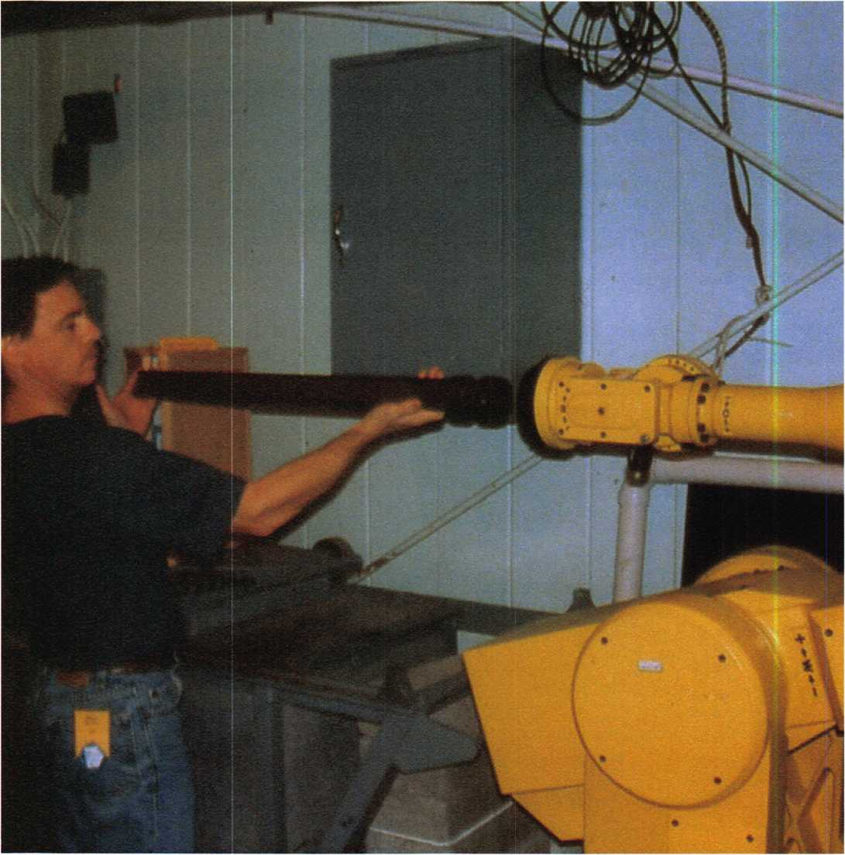

Keynotes • February 2005

The phrase “get a grip” has taken on new meaning at the University of Missouri—Rolla (UMR). The university’s Senior Design Robotics Team is testing a new procedure using a Dortronics Mini-Mite 300 Magnetic lock mounted on a robotic arm to lift radioactive control rods out of the facility’s nuclear reactor pool for inspection. Because the control rods are magnetic, Dortronics Mini-Mite 300, fit­ted to the robotic arm, is being employed as a form of robotic gripper.

“Specialized” robotic grippers can be very costly, and their implementation can be quite complicated”, said Brian Porter, Senior Electronics Technician with the UMR Nuclear Reactor Facility. “In looking for a better alterna­tive, the design team analyzed several different possible sys­tems or methods and this research led us to Dortronics’ Mini-Mite 300 because of its compact size and superior strength.

The unusual application doesn’t surprise John FitzPatrick, Vice President of Dortronics Systems, Inc. “Although the company is known primarily for its security and door con­trol hardware, the user profile for our electromagnetic locks is constantly being redefined, because of their capabilities and outstanding reputation.”, FitzPatrick says. In addition to the preassembled Mini-Mite 300 and 200N, Dortronics customizes electromagnetic locks in virtually any size or configuration, with holding strengths ranging from 25- 1500 pounds. The Mini-Mite used at UMR is capable of providing 300 pounds of holding force and has no moving parts to wear, stick or bind.

Porter said Dortronics was very receptive to the idea when approached, and showed a special interest from the first phone call. “We have been very impressed. Dortronics has responded in a speedy and professional manner, both by phone and by email.” Porter was also very satisfied with the Mini-Mite 300’s compliance with the project budget and time restraints. “As with most design teams, we have limit­ed time and funding but believe with the successful imple­mentation of an electromagnetic gripper we can complete Phase One of our robotic project on time and within budget.

UMR’s nuclear reactor is used primarily for research and training programs affiliated with the university, along with hosting Missouri high school science classes under the Reactor Sharing Program. The facility is equipped with stat-of-the-art detection instruments and associated elec­tronics for neutron activation analysis and is protected by a sophisticated, multi-genre security system including bio­metrics hardware and software.

Dortronics believes the experiment at UMR may lead other nuclear reactor facilities and other users of robotic devices to consider similar procedures. “It wouldn’t be the first time we have seen momentum develop from a unique application,” said FitzPatrick. “Robotics is quickly becom­ing a mainstream technology in the industrial sector and because our electro magnets can be universally controlled, it makes the utilization easier and more effective.

li

Keynotes • February 2005

Specialty Lock Applications:

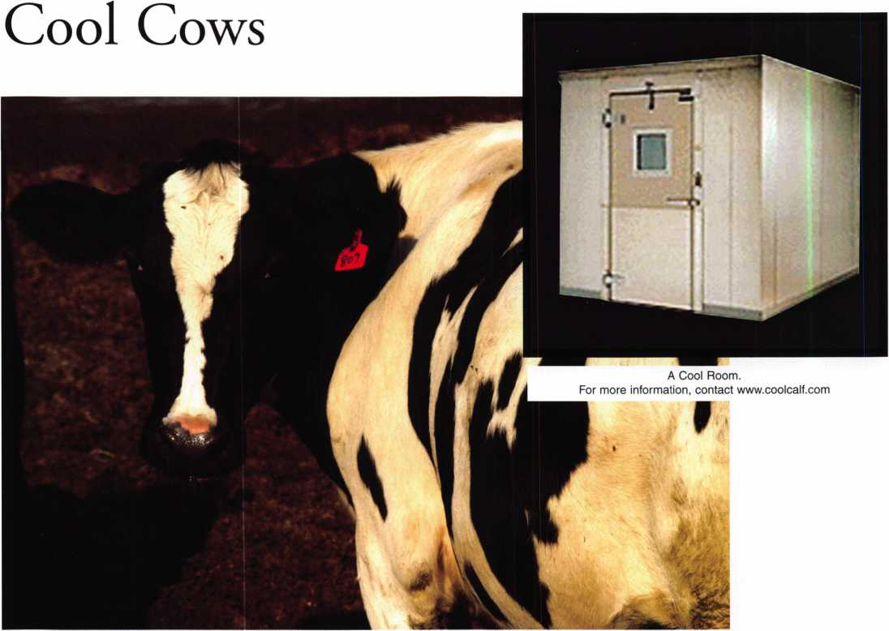

Cool Calf Company manufactures cool rooms for the show cattle industry and uses magnetic locks to seal the deal. Cool rooms are specially made to keep the cows body tem­perature low, in order to grow fur. A thick layer of fur ensures a healthy coat, hiding imperfections in the show ring. These rooms are specially crafted to be safe as well as comfortable.

Electromagnetic Door Locks:

Dortronics Systems, Inc. electromagnetic door locks are installed during the manufacturing process. If for any rea­son the power to the room is lost, the lock will release and allow the door to open allowing fresh air into the room. Since cattle confined in a insulated area put off the same amount of heat as a medium sized furnace, the lock system can also be incorporated into the thermostat so that it will open the door if the temperature of the room rises to 70 degrees.

Room Construction:

Cool Calf rooms are constructed of wood frame, foamed in-place urethane panels. The panels are 3.5” thick, and have a R-29 rating. All panels utilize tongue-and-groove construction for stability and lock together with a cam locking system. Gaskets seal each panel where panels are joined. The locking of the panels are performed by Cam locks which are installed on the tongue side for the locking system. Cam locks have been the preferred locking system in the walk-in cooler industry for the past 15 years. The exterior of the panel is finished with 26 Ga. embossed gal­vanized with white finish available at additional cost.

Doors are available in 36” and 48” widths, and 78” heights. The doors are built of the same insulating material as the room is constructed. Panels are built in T, 2’, 3’ 4’ widths and palletized for easy shipping.

**12**

Keynotes • February 2005

Mul-T-Lock

Always Ahead of the Game

Throughout the world, as new locks are constantly emerging,  
modern cylinder manipulation techniques along with familiar  
methods such as picking, drilling, and bumping continue to sur-  
face. With the known dangers growing on a day-to-day basis,  
some threats can become extremely prominent in certain parts of  
the world, while remaining virtually unheard of in others. But as  
each of these techniques becomes more and more eminent here  
in the US, it is important to know that your high security  
provider of choice is equipped to meet the challenge.

MUL-T-LOCK’s global presence has given them a clear advan-  
tage in anticipating threats to high security. Having been exposed  
to cylinder manipulation techniques the world over, MUL-  
TLOCK wisely incorporates this knowledge into their product  
development, resulting in cylinders that are armed to defend  
against even the most obscure of dangers.

For over 30 years, MUL-T-LOCK has been providing high secu-  
rity solutions that exceed most common requirements by meet-  
ing a great number of international standards for quality. In  
addition to obtaining an impressive UL 437 rating, MUL-T-  
LOCK has passed tests presented by organizations like CEN,  
VDS, SKJ, and many more. Such international standard institu-  
tions are known for implementing severe and relevant testing  
that is specific to each domestic market. MUL-T-LOCK has suc-  
ceeded in gaining a significant edge in the industry by surpassing  
these requirements, and as a result, their products are designed in  
a collaborative effort to meet a vast array of worldwide strength,  
endurance, and reliability challenges.

As a global leader in the high security industry, MUL-T-LOCK  
has not only succeeded in meeting such international criterion,  
but has taken great pride in working hard to provide preventative  
solutions that aim to eliminate security risks before they begin.  
Such pre-emptive measures are especially evident in solutions  
such as the following:

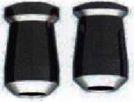

1. MUL-T-LOCK's stainless steel mushroom pins are tapered and shouldered to create  
"false" shear lines while picking or bumping is being attempted.

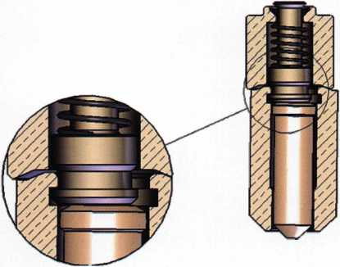

2. MUL-T-LOCK's patented anti picking pin set. When these pins coexist in a particu-  
lar chamber and work with one another it makes it virtually impossible to pick the  
cylinder% as any time tension is applied[ the top and bottom pins interlock. This will  
deter the most determined lock manipulator.

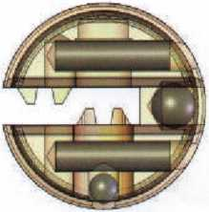

3. MUL-T-LOCK's enhanced anti-drilling pin design.

All of these features were carefully constructed to defend against picking drilling, and bumping at a time when the latter of these methods was not yet even a mainstream concern. In addition, MUL-T-LOCK is probably the only manufacturer in the United States that is cur­rently offering the stainless steel mushroom pins to defend against key bumping.

Thanks to such anticipatory manufacturing methods, MUL-T-LOCK is often prepared to provide an answer long before the question is raised. The reassuring nature of MUL-T-LOCK’s devoted attention to product design along with their commitment to customer service and support have made them a highly preferred partner of choice to security professionals around the globe.

As new security threats are discovered or as old familiar dangers are revisited, rest assured that MUL-T-LOCK is always one step ahead of the game, using their worldwide experience to keep us safe and secure.

For more information on MUL-T-LOCK’s high security solutions, log on to [www.mul-tlockusa.com](http://www.mul-tlockusa.com), or send your email to [info@mul-t-lockusa.com](mailto:info@mul-t-lockusa.com).

The Agnus Dei Safe

by Dave Thielen, CML

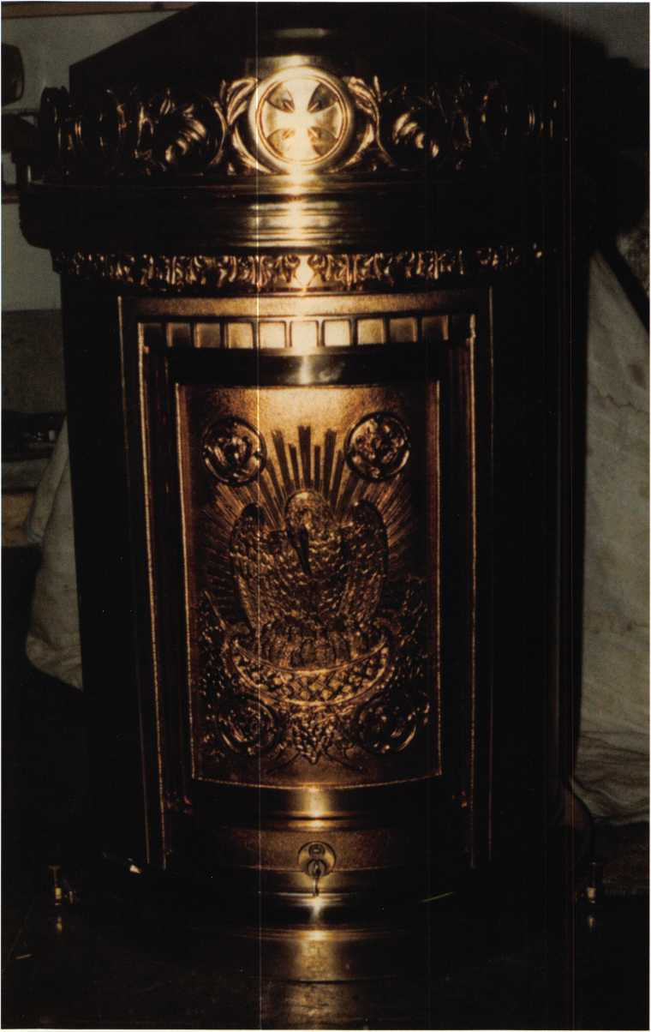

Photo 1

One of the things I enjoy most about being a locksmith is the endless variety of locks and locking devices to work on. I have been asked (and paid) to make keys or repair locks on flag poles, paper cut­ters, pool tables, pencil machines, guitar cases, jewelry boxes, VCRs, thermostats, zip­pers, light switches, ski racks, wheels, hub caps, and more.

The endless variety makes for interesting work and keeps your skills sharp when trying to figure out how a particular device works.

I received a phone call from a local Catholic Church asking me to rekey a safe. Not know­ing what they had, I asked a few questions:

1. Are there names and numbers on the safe?
2. Is there a combination lock as well as a key?
3. Does it use 1 or 2 keys?
4. Is the key flat or round?
5. How old is the safe?
6. How large is the safe?
7. Why does it need to be rekeyed?
8. Is the safe open or locked?

The priest explained that he was using one key to operate the lock, but the second key was missing, thus the request

Keynotes • February 2005

Photos 2 and 3

Photo 5

Photo 4

the rekey. There was no  
combination lock, only 1  
flat key. There were no  
names or numbers on the  
safe. The container was  
considered to be “very old  
and very special”. The only

information they had were  
some markings on the key

reading “Agnus Dei Safe”.

“Oh! One of those!”, I  
responded (pretending to  
sound confident even  
though I had no idea what  
kind of safe we were dis-  
cussing). I then jotted

down the information and wondered what I was getting myself into.

Arriving at the church, the priest led me to a beautiful ornate container and said, “Here is the safe I want rekeyed.” (photo 1)

I soon learned that this container was not really a safe, but a Tabernacle. A tabernacle is a case or box that sits on a church altar. It contains the conse­crated host of the Eucharist.

“Can you do the job?”, the priest asked as he handed me the key (photos 2 and 3). After studying the key and lock mechanism for a few minutes, I agreed and felt I was ready to take on the challenge.

Photo 6

Photo 7

Keynotes • February 2005

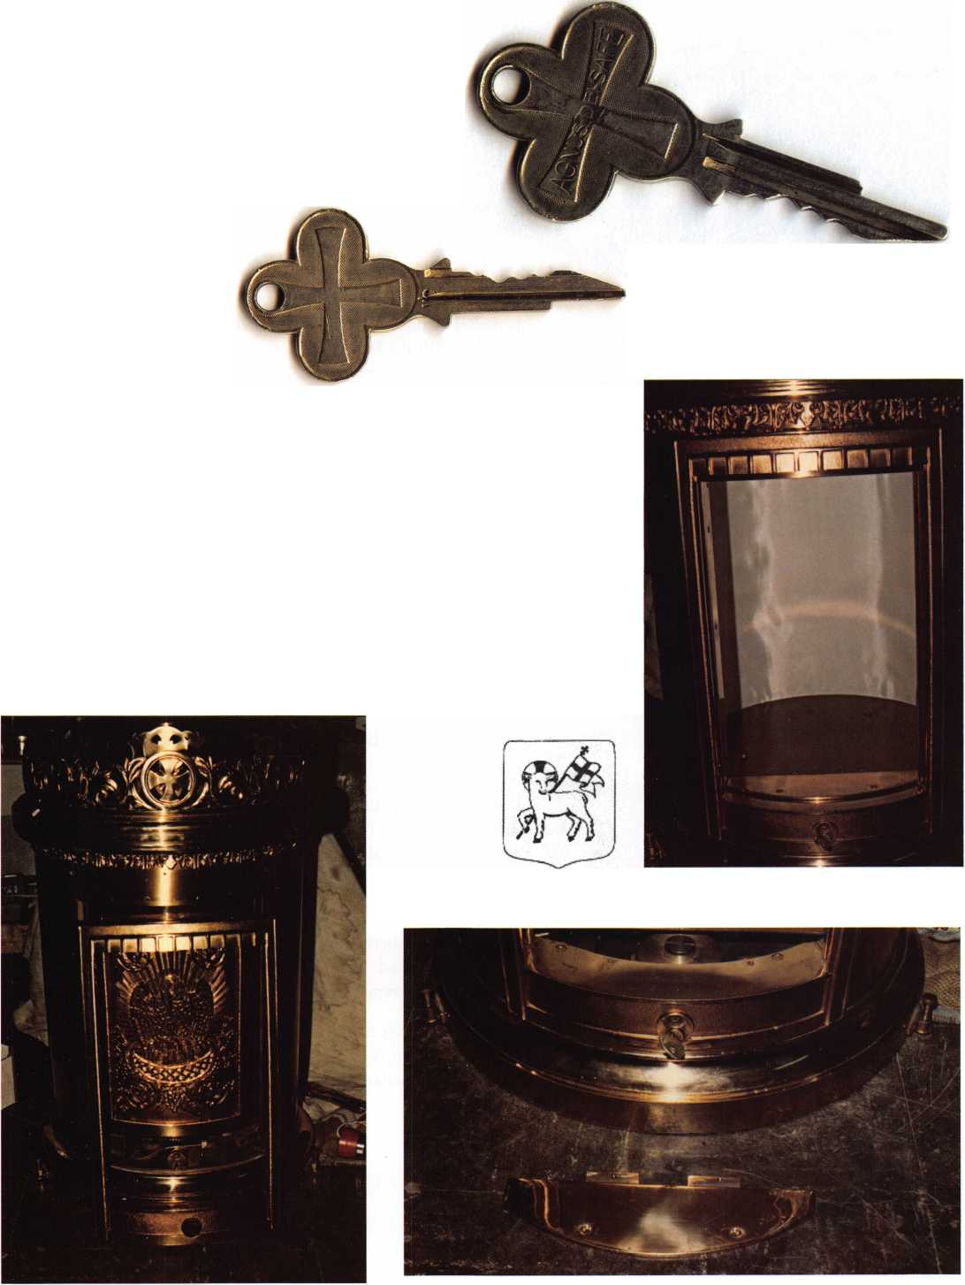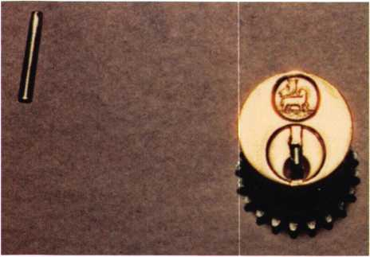

Photo 8

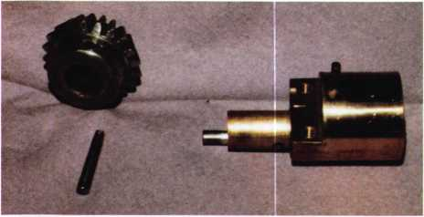

Photo 9

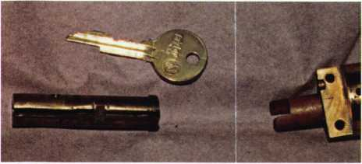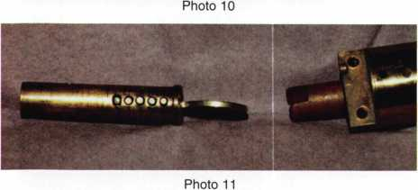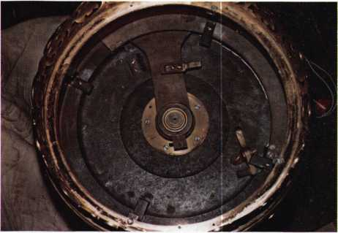

Photo 12

The Tabernacle was loaded into my truck for a trip back to the shop where I would be sure to have a good light source and all available tools. Also, I didn’t want to look puzzled in front of the priest.

Agnus Dei is Latin for “lamb of God” (photo 4). This figure also appears on the front of the cylinder. A little investigation revealed a Yale pin tumbler cylinder with a VC keyway and a 6-pin key. An Ilco 998 VC was used in the rekeying process.

As I did not want to scratch or mar this work of art, I proceeded to disassemble the locking mechanism with extreme caution.

Photo 5 shows the Tabernacle with the key turned and the door opened. The door rotates in a circular motion and operates very smoothly with the key. Photo 6 shows the crescent-shaped piece removed to gain access to the lock cylinder. Photo 7 shows the shroud removed from around the front of the lock cylinder. Photo 8 shows a close-up view of the cylinder and geared mechanism used to operate the door. 4 Screws on top of the mechanism were loosened to allow the cylinder to be removed from the Tabernacle.

The cylinder also had a large gear attached to the back with a roll pin (photo 9). This pin extends into the plug and explains the notch in the tip of the key (photo 10).

Photo 11 shows the plug rekeyed and ready to reassemble. Standard Yale depth and spaces were used. A standard plug follow­er and Lab pins were used. Although it was a 5-pin lock, a 6-pin key was needed with a notch tip at the bottom.

Photo 12 shows the crown top of the Tabernacle removed. In this photo you can see how the door revolves with a counter-weight system.

Having completed the rekeying job, all that remained was the careful reassembly of all the pieces and parts. After checking the key operation several times and wiping off fingerprints and smudges, I was satisfied and honored to have worked on this spe­cialty lock.

Returning the Tabernacle to the church, the priest asked, “How did it go?” I replied, “No problems.” I didn’t feel it was necessary to explain my nervousness to work on this beautiful work of art.

He thanked me for my service and said, “May God be with you”.

I thanked him for the opportunity and left for my next service call, wondering what type of specialty lock awaited me.



Keynotes • February 2005

Important' Information for locksmiths from the

fl.3. Batriot act

§ 1386. Keys and keyways used in security applica­tions by the Department of Defense

(a)

1. Whoever steals, purloins, embezzles, or obtains by false pretense any lock or key to any lock, knowing that such lock or key has been adopted by any part of the Department of Defense, including all Department of Defense agencies, military departments, and agencies thereof, for use in protecting conventional arms, ammuni­tion or explosives, special weapons, and classified infor­mation or classified equipment shall be punished as pro­vided in subsection (b).
2. Whoever-
3. Knowingly and unlawfully makes, forges, or counterfeits any key, knowing that such key has been adopted by any part of the Department of Defense, including all Department of Defense agencies, military Departments, and agencies thereof, for use in protecting conventional arms, ammunition or explosives, special weapons, and classified information or classified equip­ment; or
4. Knowing that any lock or key has been adopted by any part of the Department of Defense, including all Department of Defense agencies, military departments, and agencies thereof, for use in protecting Conventional arms, ammunition or explosives, special weapons, and classified information or classified equipment, possesses any such lock or key with the intent to unlawfully or improperly use, sell, or otherwise dispose of such lock or key or cause the same to be unlawfully or improperly used, sold, or otherwise disposed of, shall be punished as provided in subsection (b).
5. Whoever, being engaged as a contractor or oth­erwise in the manufacture of any lock or key knowing that such lock or key has been adopted by any part of the Department of Defense, including all Department of Defense agencies, military departments, and agencies thereof, for use in protecting conventional arms, ammuni­tion or explosives, special weapons, and classified infor­mation or classified equipment, delivers any such fin­ished or unfinished lock or any such key to any person not duly authorized by the Secretary of Defense or his designated representative to receive the same, unless the person receiving it is the contractor for furnishing the same or engaged in the manufacture thereof in the man­ner authorized by the contract, or the agent of such man­ufacturer, shall be punished as provided in subsection

(b).

(b) Whoever commits an offense under subsection (a) shall be fined under this title or imprisoned not more than 10 years, or both.

1. As used in this section, the term "key" means any key, keyblank, or keyway adopted by any part of the Department of Defense, including all Department of Defense agencies, military departments, and agencies thereof, for use in protecting conventional arms, ammuni­tion or explosives, special weapons, and classified infor­mation or classified equipment.

US CODE: Title 18, 1386.

Keys and keyways used in security applications by the Department of Defense

Release date: 2004-08-06

Cabinet Lock Choices

By Greg Perry, CML, CPS

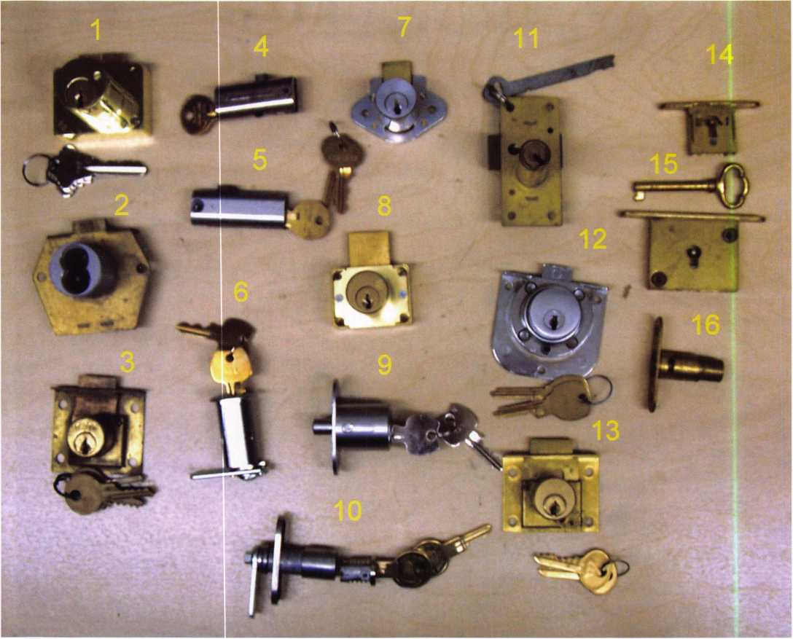

Photo 1

Keyed cabinet locks, they come in a wide variety of styles, shapes and keying possibilities. New installations are not difficult but replacing existing locks can be challenging. Most locks are available to us, either through a locksmith distributor or direct from the manufacturer. Others are no longer produced. Some give no hint as to who manufac­tured the lock or where to find a replacement. We’ll look at some of the locks available and also look at where to get some hard to find locks. A series of questions are needed to select and narrow your choice:

* Is this a new installation or are we trying to replace an existing cabinet lock? New installations allow us to choose the lock Replacing existing locks can be a little challenging if the lock is no longer manufactured.
* Regarding new installations, ask “how secure?” Does the application require a high-security drill and pick- resistant lock, will a pin tumbler lock suffice, or will a disc tumbler or lever lock provide the appropriate level of security? Pin tumbler versions will typically be a small pin tumbler, although some offer larger or full-

**18**

Keynotes • February 2005

size keying options. Generally, the labor to install the lock is far greater than the cost of the lock. Using the better quality locks makes sense unless you are replac­ing an existing lock.

• The next question to ask is, “What type of material?”

Is it metal, wood, or some other material like plastic or glass? How thick is the material and what is the bolt or cam going to lock into or behind?

After answering these questions we can select between the various types of locks available. Let’s look at some of the locks available along with their respective strengths and weaknesses.

The most basic option is a cam lock, photo 1 (number 6). Cam locks are measured from under the face to the under­side of the cam (without offset). Typically, most brands are available in lengths 3/8”, 5/8”, 7/8”, 1 1/8”, 1 3/8” and 1 3/4”. Cam locks are typically inexpensive and easy to install. They are constructed with an outer shell and an

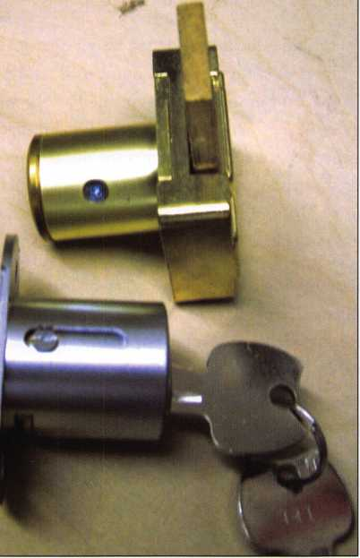

*mmm*

Photo 2

inner plug. After inserting the key, the inner plug turns the cam typically 90 or 180 degrees. A variation is the “T” bolt that travels up and down to lock. These locks are very pop­ular in the center drawer of a desk. Cam locks are installed in a double-D-shaped hole or a round hole with a spur washer or plate to keep the outer housing from turning. A double-D hole punch is available from Major Mfg. for use on up to 18-gauge steel. If the metal is thicker than 18 gauge, the easiest method is to use double stick tape and a plate with the double-D cutout to prevent the lock from rotating. Installing in wood and plastic requires drilling a hole and using a spur washer or plate with screws. The biggest advantage to using cam locks is versatility. The cam can be straight or offset to compensate for different loca­tions between the end of the cam lock and the strike.

Cams can also have hooks that work well in sliding door applications. There are also disadvantages to cam locks. As the double-D hole wears, the lock will begin to turn in the hole, perhaps unlocking. Also, the nut holding the housing can loosen, again allowing the lock to turn. The locks are

**New!** Keedex Stainless Steel Armored Door Loops

ALL

STAINLESS STEEL  
DESIGN

STAINLESS

CONDUIT

AVAILABLE FROM YOUR KEEDEX DISTRIBUTOR

MADE IN U.S.A.

STAINLESS STEEL  
END PIECES

STAINLESS STEEL

MOUNTING SCREWS

COSTS NO MORE  
THAN MOST DOOR  
LOOPS THAT HAVE

PLASTIC END PIECES

Call or write today

for yourfree catalog!



Keedex, Inc.

12931 Shackelford Lane  
Garden Grove, CA 92841  
714-636-5657 • Fax: 714-636-5680  
e-mail: [info@keedex.com](mailto:info@keedex.com)

[www.keedex.com](http://www.keedex.com)



Keynotes • February 2005

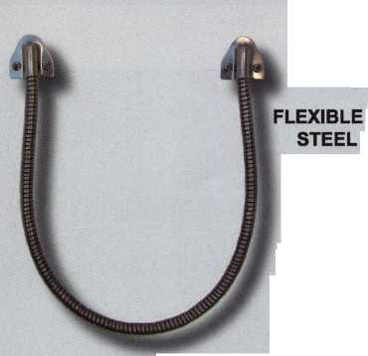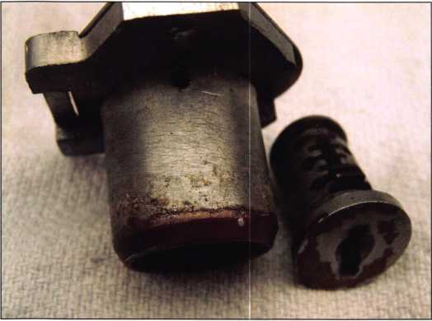

Photo 3

Photo 4

Photo 5

normally produced with diecast metal leaving the cam connection area susceptible to breaking or possibly the cam, made of steel, can be easily bent.

Door and desk locks are lumped together since the main difference is the keyway orientation. Drawer locks orient the keyway and bolt vertical, while door locks orient the bolt horizontal, with the keyway in a vertical position.

Some manufacturers supply the same lock for both applica­tions. Diamond-back locks like the Ilco 1701 or Olympus R078 locks are named because of their shape. Photo 1 (lock number 7) is a diamond-back lock. They are typically avail­able in 7/8” and 1 1/8” lengths. Simple to install, they offer minimal security. The bolt throw is short (at about 1/4”).

Its also flush with the inner surface of the lock mounting plate. This can create a problem if the door or drawer sits on the surface of the face frame. If the door or drawer has a little flex the bolt can be bypassed. A better choice is to use a square body lock, photo 1 (lock number 8), like the CCL 0737 or 0738, the Olympus 100 or 200 series or the National C8138. They come in lengths from 7/8” to 1 3/8”. These locks have 1/8” gap between the lock mounting face and the bolt. This allows for a strike to be installed. A dif­ferent option is to space the lock back from the mounting surface and latch in behind the face frame.

Other cabinet locks include bypassing door locks. The Olympus 300, photo 1 (lock number 9), and the Chicago 1770 have a pin that extends for the back between two slid­ing doors. Chicago also has a 1775 version that turns to engage the strike. This prevents the doors from being spread apart to bypass the lock. The lock shown in photo 1 (lock number 16) is a National Lock lever-lock version of the slid­ing door lock.

Disassembling these locks to rekey or make a key can be a challenge. Some have an obvious method, others require prior knowledge. Most pin tumbler locks have a screw, a push-in retainer or some obvious method of disassembly. Photo 2 shows a couple of pin tumbler lock retaining screws. Disc tumbler locks can be a little more challenging. A poke hole or screw is an obvious invitation. Some locks require guessing the location of the retainer and drilling your own poke hole. In general the plug must be at the cor­rect location to line the retainer up with the poke hole. A diamond-back lock with the poke hole is seen in photo 3.

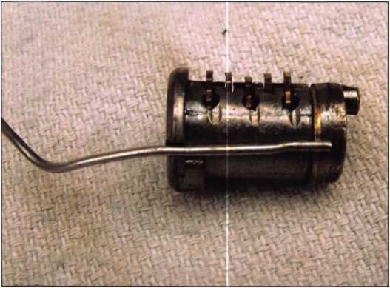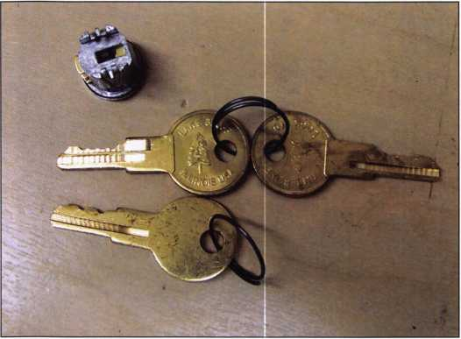

**20**

Keynotes • February 2005

Normally, this is found in the unlocked position, or halfway between the locked and unlocked positions. Chicago 1974 and 1975 locks require the plug to be turned 90 degrees before a poke tool with bevel on the end is inserted past the half-moon retainer. Next, turn the tool 180 degrees and extract the plug. Sometimes this is easier said than done. A picture of a paperclip with the beveled end and a plug are seen out of the housing in photo 4. Timberline has a removal key (part number D500KY). The key (seen with a pair of operating keys in photo 5) is shorter than an operat­ing key. It also is milled to operate the lock on the master key side of the wafers. This allows the plug to turn an addi­tional 90 degrees to release it from the housing. Timberline is unique. All the housings accept the same plug. The only difference in plugs is the face finish. Others, like Harpers, have a different method of extraction. The lock plug is turned to the unlocked position. Next, use either a pick or a removal key to move the last wafer, and extract the plug. Photo 6 shows a rekeyed plug with the factory removal key. It is longer, and like the Timberline, is milled to lift the wafers on the opposite side of the keyway. These plugs are so easy to remove with a pick that I rarely use the key. Diebold uses a special cabinet lock from National Lock in their teller cabinets. One of these locks can be seen in photo 1 (lock number 12). It requires a flat steel key available from National Lock. The key is inserted into the back of the lock housing and turned allowing the cylinder to be removed form the front.

A variety of half mortise pin and disc tumbler locks have been produced over the years. Some of these like the Yale lock shown in photo 1 (lock number 3) are no longer avail­able and are difficult to replace. Others, like lock number 13, are still produced by National Lock or CCL. Unless I can find an exact replacement I tend not to use these types of locks. Installing one of these locks on an already assem­bled drawer can be very challenging.

Some of the oddball cabinet locks include the mortise and half mortise desk and drawer locks. Typically, these use flat steel, bit or barrel keys. Photo 1 lock numbers 11, 14, and 15 show a few of the styles available. A few are available from National Lock. Others, you’ll have better luck finding outside of normal distribution channels. Woodworkers Supply ([www.woodworker.com](http://www.woodworker.com)) and Rockier ([www.rockler.com](http://www.rockler.com)) among others have a selection of these

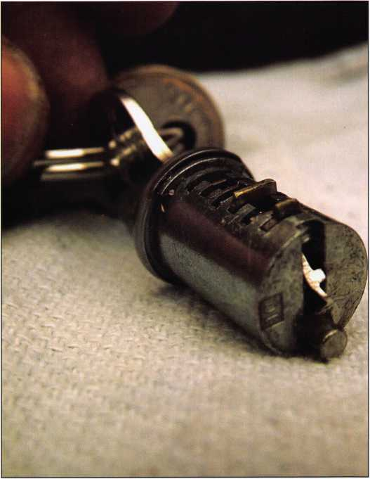

Photo 6

Professional Business Products

We donate 5% of all sales to the  
**ALOA Scholarship Fund**Buying from NEBS®?

We offer lower prices on invoices/workorders, checks,  
repair tags, magnets, business cards, key tags and more.

[www.pbp2000.com](http://www.pbp2000.com)

**ADVERTISE WITH  
OUR**

**WEATHERPROOF**

**LABLES**

Keynotes • February 2005

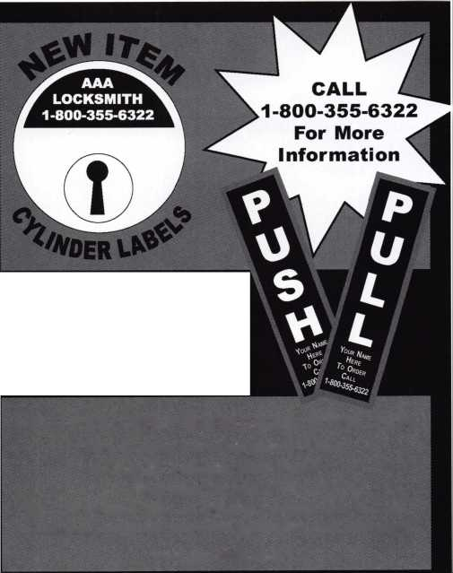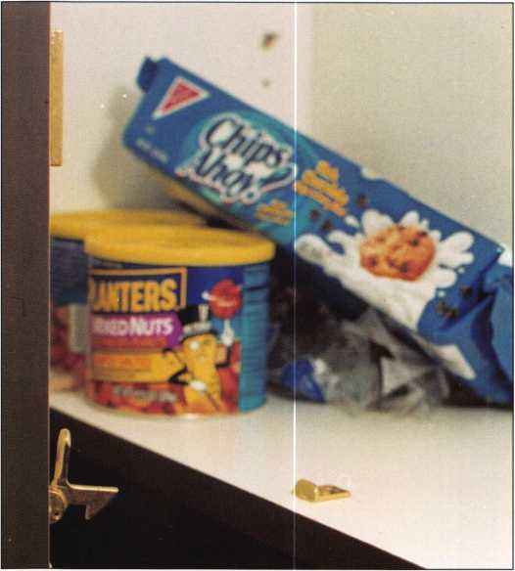

locks. They are used in a variety of applications from roll top desk to jewelry boxes.

Several other manufacturers produce cabinet locks. Abloy, Medeco and others offer high security locks. If they don’t have what you are looking for, check with RA-Lock at (214) 291-1301. They have modified or produced a wide range of specialty cabinet locks.

We’ll quickly go though a recent install of an Olympus 100DR cabinet lock. The cabinet has two doors. First, the inactive door is locked with an Ives 2A4 elbow catch seen in photo 7. Next, a cabinet lock installation jig (photo 8) from Major Mfg. is used to assist in drilling the hole through the door. A jig was used to maintain the exact distance from the edge of the door, since this install involved 6 sets of doors. Once the lock is installed, a strike is installed on the back side of the inactive door to complete the installation. The strike can also be seen just above the peanuts in photo 7.

Photo 8

Hopefully, this article helped you with cabinet lock  
service and gave you some hints on where to find some  
of the oddball locks. Cabinet locks will not make you  
rich, but if you are properly equipped and prepared  
they can add nicely to your bottom line.

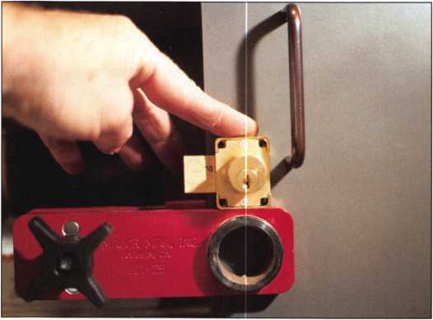

Photo 8

Photo 9

**22**

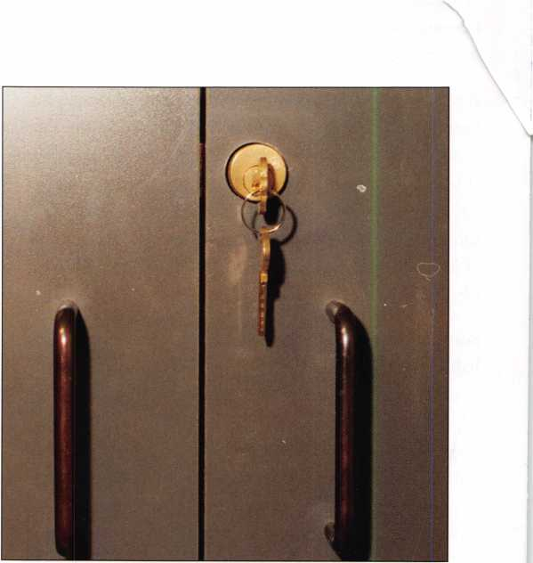

Keynotes • February 2005

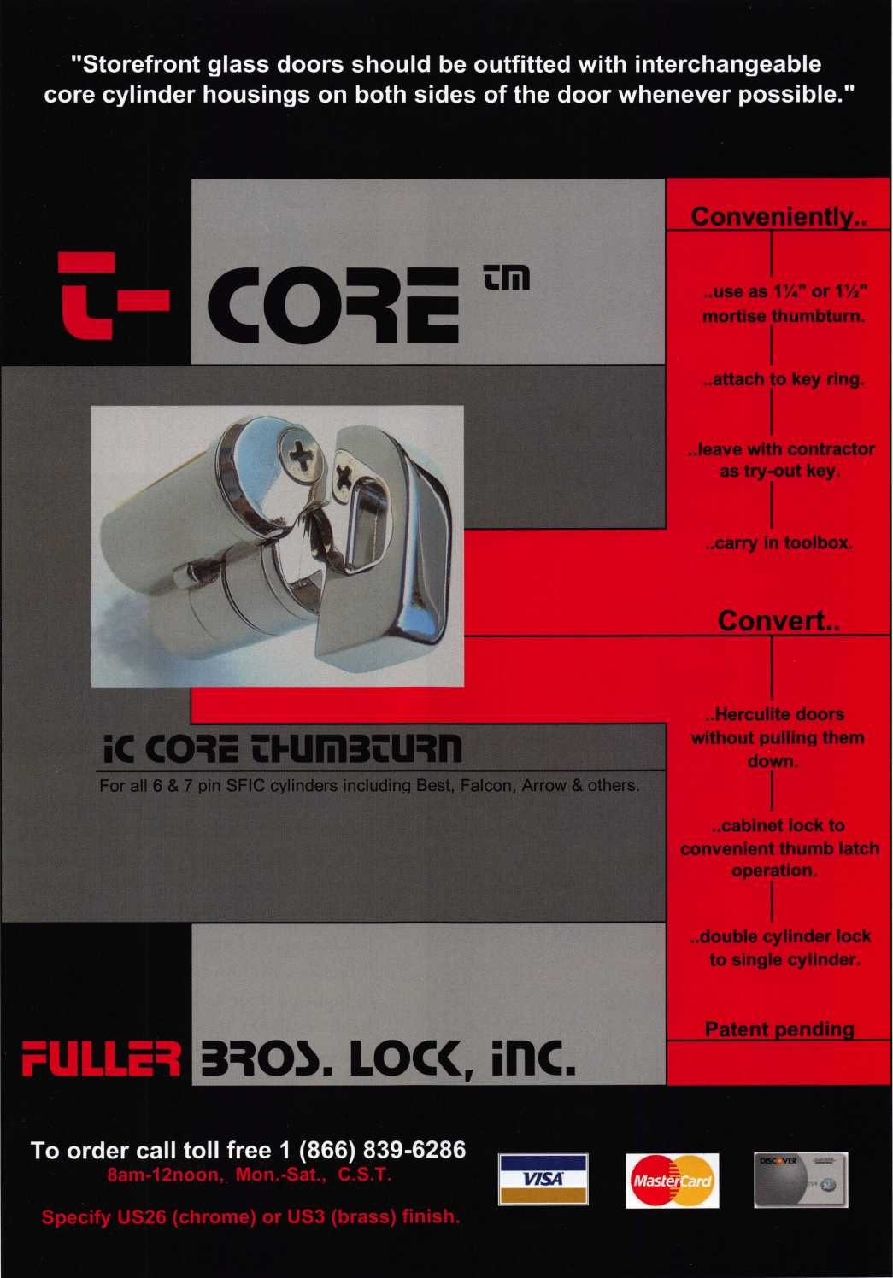

Pocket Door Solution

By Greg Perry, CML, CPS

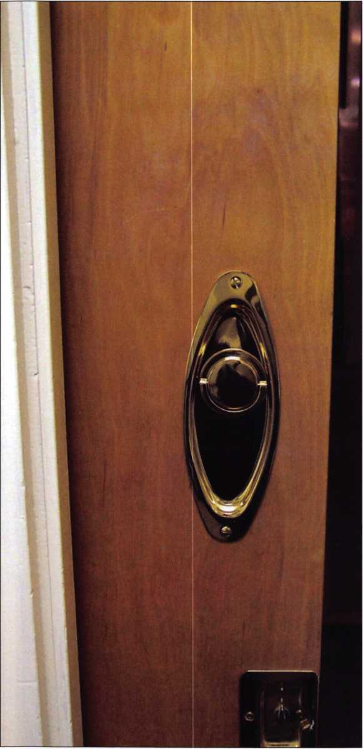

Photo 2

A customer recently asked me to install a  
lock he found on the Internet on a pocket  
door. Its a 9200 series pocket door lock  
manufactured by Von Morris. I’ve installed  
Adams Rite hookbolts for this application  
but the hook-to-strike connection can be a  
little loose. Von Morris manufactures a line  
of high-end door hardware similar to  
Baldwin. They sell everything from hinges to  
Creomone bolts (and even humidor box  
locks). The pocket-door lock retails for close  
to $200.00. This is not an inexpensive solu-  
tion but, compared to a new door and  
frame, perhaps it is a better idea.

**24**

Keynotes • February 2005

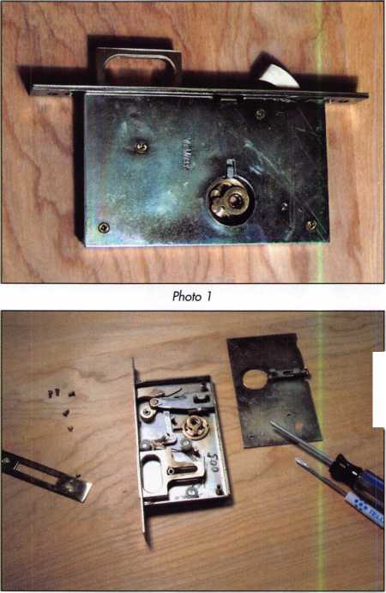

The only instructions are on the templates. Operation appears simple, but without instructions you might miss one feature at first. The bolt does double duty. When you push in on it while it is retracted, out pops a pull out. Also, it extends with a turn of the key or thumb turn. Photo 1 shows the mortise lock case with both the bolt and pull extended. A look inside (in photos 2 and 3) reveals a simple construction. The bolt is deadlocked when it is extended. The L-shaped arm that comes down from below the bolt releases the pull. The lock case is the same for both a single-cylin­der and the double-cylinder versions. The difference is in the trim. This lock came with the T-turn hub pre­installed. If the hand is incorrect, simply back out the cylinder retaining screw and swap the hub to the other side.

This lock is not the easiest to install. First, the mortise pocket is only 9/16” wide. Most mortising tools are

designed for a wider pocket. This means a hand-cut mortise. Start the install by taping the paper template to the door as seen in photos 4 and 5. (I like to mark the door with an automatic center punch in case the paper template tears.) I used a 9/16” spade bit and a chisel. The advantage to a spade bit is the ability to clean the edges of the hole or pocket. A series of holes were drilled to follow the template guidelines. I then used the bit, moving it up and down in the pocket, to reduce the amount of chiseling. Next I drilled the cylinder hole through the 1 3/4” door. If you are installing on a 1 3/4” thick door, you will need to drill a cylinder hole. This door is only 1 3/8” so drilling the hole was an unnecessary step for me. The instructions call for a 1/4” deep pocket on faces. This would leave only 3/32” of material left after cutting the mortise. 1 3/4” doors have an additional 3/16” of material left on each side. This is a good place to remind you to take the right size chisel. I forgot a

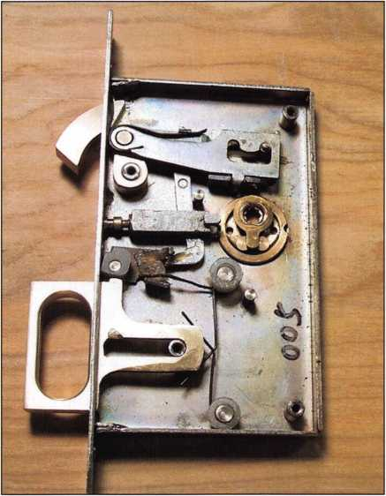

Photo 3

Don’t Miss Your Chance to learn from the

AUTOMOTIVE EXPERTS

*20057&9T*

Feb. 19 8: 20 Jacksonville, FL

March 16 - 18

April 23 & 24 May 13 - 15

Aug. 22 - 26 Sept. 17 a 18 Oct. 12 - 14

Texas Locksmiths Association Show  
Corpus Christi, TX

Pittsburgh, PA

West Michigan Locksmith Association  
Kalamazoo, Ml

LSI Facility - Nicholasville, KY  
Kansas City, KS

Pacific Locksmith Association Show  
Portland, OR

£005 'fveoc/ifrUpdated with the Latest Information!

Domestic Automotive • Import Automotive  
High Security Automotive • Advanced Transponders

Key Generation • Electronic Safe Lock Servicing

Tie™ f Safe Deposit Lock Servicing

**Call 800.654.0637 or Visit  
pureauto.com to Download  
a Registration Form.**

Keynotes • February 2005

**25**

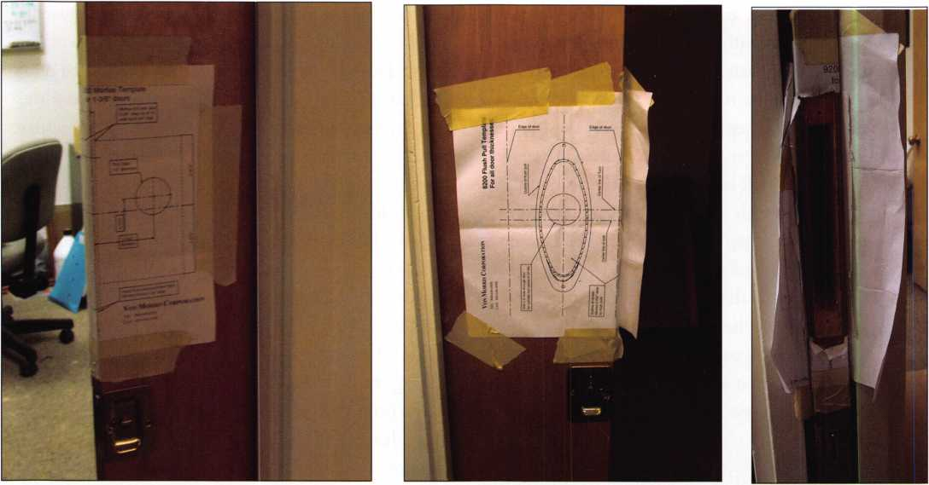

Photo 4 Photo 5 Photo 6

1/2” chisel, forcing me to widen the top and bottom  
of the mortise pocket to 3/4”. This was not a huge  
problem, since the faceplate covers it, however. After  
cleaning up the cutouts (seen in photos 6 and 7), I  
tested for fit. The parts didn’t fit! I set the trim on a  
spare copy of the template. Photo 8 shows the prob-  
lem, they don’t match. I needed to enlarge the mor-  
tise pocket and the trim holes. This added an extra  
43 minutes to the job.

The installed lock can be seen in photos 9 and 10.  
The outside view is shown with the supplied 5/8”  
mortise cylinder. Even with the very short cylinder  
on a 1 3/8”, door the cylinder needed a trim ring  
that wasn’t supplied. The customer needed it keyed  
to match his 6-pin master key system. This created  
another problem. The doorframe needed to be cut  
for the cylinder to clear the cylinder. I started by  
using a spade bit to cut a pocket, a similar idea to  
cutting the mortise pocket. The doorframe contained  
some steel that was cut with a pair of tin snips. This  
pocket can be seen in photo 11. The final item to  
install was the dust-proof strike. The template was  
also sized wrong for this so I made the cutout by  
hand and installed it. The strike seen in photo 12  
shows both the face of the strike and a side view with  
a pocket screwdriver through the strike hole.

**26**

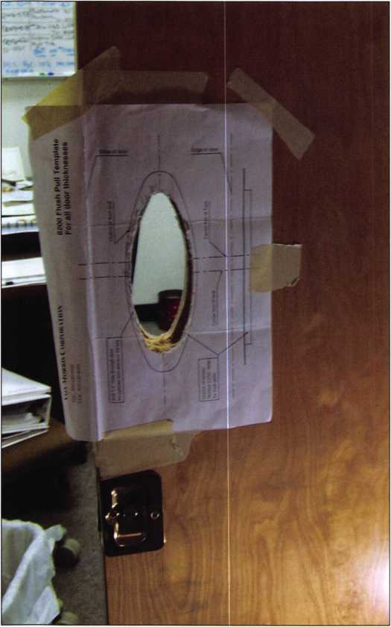

Keynotes • February 2005



**RING of a KING**

Member Name Sponsorships

Kwok-kei Leung 219

Henry W. Raymond 92

Yuriko Yanai 82

Mary S. Ohmit CPL 66

Charles C. Robertson CML 65

William Lee CRL 55

Jack HobinCPL 51

Clifford D. Lipscomb CML, CPS 47

Michael B. Groves 43

C Allan Halverson 40

David M. Troiano 40

Myeong-Rae Cho 38

Jim Williams CRL 38

David M. Lowell CML, CMST 36

Salvatore J. Dulcamara CML 36

Dana L. Barnum CML 35

Barry K. Leas CRL 35

Danny W. Rudd CPL 33

William L. Young CML, CPS 32

Larry A. Wamick CML 31

Eugene R. Altobella Sr 31

Jeanne G. Lodge CML 30

Robert D. DeWeese CML 30

John C. Elliott Jr, CML, CPS 28

Robert W. Duman Sr, CML 28

Scott L. Henke CPL, CPS 28

Dallas C. Brooks 28

Ken Dale 28

Breck H. Camp CML 27

Lawrence F. Smith Jr, CML 27

Marian M. Swann CRL 27

James M. Watt CML, CPS 27

William T. Beranek 27

Anthony J. Ramunno CML, CPS 26

Jeffrey S. Nunberg CML, CMST 26

J Thomas Hood CML 26

John L. Shandy CML 25

Elvis D. Hammerschmidt CPL 25

Robert H. Stafford CML 25

Philip A. Rovenolt CPL 25

Jerome L. Cohen CML 23

Peter K. Gauthier CPL, CPS 23

Man-Soo Seo RL 23

James J. Cawby CML, CPS 22

James L. Hancock CPL 22

Hans Mejlshede CML 21

Peter Sarailian CRL 21

John S. Dorsey CML, CPS 20

Thomas G. Vandersteen CML, CPS ..

Walter W. Lascar RL

Keizo Takahashi CRL ....

James E. Fowler Sr, CML

David C. Harris CML

Ronald E. Heidzig

Joe J. Lee CRL

Takashi Kuwana CRL ....

Eugene R. Altobella Jr ....

Ernest W. Wright

Peter R. Hall

William P. Grant CRL 17

James E. Gruber CPL 17

Evelyn V. Wersonick CML, CPS 16

Joseph P. Ferrero CML 16

Gary F. Teams CPL 16

Kenneth E. Kim CRL, CPS 16

William J. McElheney CML 16

John W. Soderland CML, CMST 16

Michael E. Jordan Jr, CML 16

Jon B. Griswold CML 16

Brian J. Reetz 16

John A. Ilk CRL, CPS 16

Russell P. Fuller CRL 16

Robert C. Rodocker CPL 15

John J. Greenan CML, CPS 15

Steve L. Cothran 15

Leonard J. Passarello CPL 14

Bruce J. Tarbet CML, CPS 14

John D. Cannon CML 14

Paul M. Souber 14

James T. Brickler CPL 14

Calvin G. Harris CML 13

Frank D. Hartung CML 13

Rolando Bouza 13

Timothy J. Moore CRL 13

John F. Engel CRL 13

Donald H. Shiles RL 13

Richard C. Sievers 13

Brooke P. Berry CRL 13

William J. Wickward CML 12

Raymond C. Lusk CML 12

Robert M. Massard CRL, AHC 12

Gregory L. Perry CML, CPS 12

Eric F. Veal 12

Barry L. McMenimon CPL 12

Thomas J. Demont CML, AHC 11

Basil W. Shannon CPL 11

Ralph O. Warren CML 11

Gordon R. Racine CML 11

Kevin R. Wilson CML, CPS 11

Timothy K. Chow 11

Dale L. Knowles CPL 11

Andrew A. Edmunds CML, CPS 11

Marian E. Sagar 1 1

Daniel S. Enriquez CRL 11

Gene Eldridge CPL 10

Ronald P. Riggins CML 10

Charles E. Haas CML 10

Robert E. Mock 10

Lester S. Brodsky 10

Larry L. Votaw CML 10

Thomas R. Smith CPL 10

Todd K. Ladwig CML, CPS 10

William! Straub CML 10

Michael C. Olson CRL 10

Randy L. Hutchison CRL 10

Richard T. Johnson CPL 10

Vincent L. Formon CML, CPS 10

Carroll T. Croson Jr 10

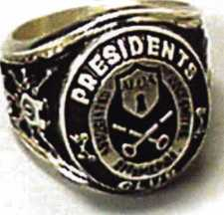

How can I join the President's Club?

You can earn a membership in this prestigious club by recruiting  
just 10 new members for ALOA.

*With the exception of Board Members, any  
ALOA Member may participate.

What do I get?

When you recruit 10 members, you receive a choice of  
receiving a handsome blue blazer with a  
President's Club crest or a ring.

You also get the satisifaction of knowing that you are  
helping your association, helping your industry grow,  
and you are helping fellow locksmiths achieve success.

How do I get started?

Mail the form below to the ALOA office for a supply of  
applications (800) 532-ALOA or FAX (214) 827-1810.  
One President's Club credit is awarded for each new  
applicant. Credit is awarded only after the membership  
application is Approved. However, the credit will apply  
for the period in which the application is received.  
Failure to identify yourself as the sponsor on the applica-  
tion form at the time it is submitted to ALOA for process-  
ing will forfeit any credit.

Name

Yes! I want to join the ALOA President's Club.

Please rush me applications so I can start earning credit toward membership in the club!

Company

Address

City

Zip

Mail this form to ALOA • 3003 Live Oak • Dallas, Texas 75204-6186

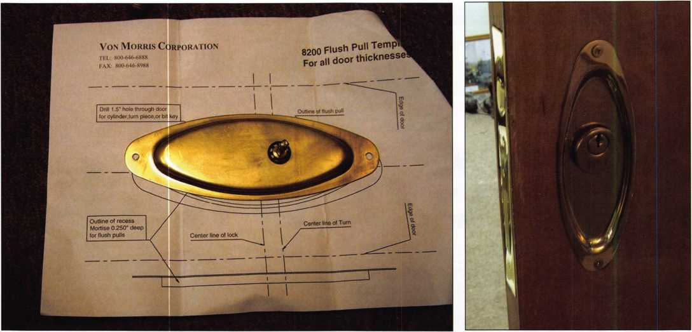

Photo 8 Photo 9

This installed required over 4 hours of my time. I think with a little practice you might get down to around 2 1/2 to 3 hours. Including the price of the lock, it makes for an expensive lock installation, I charged over $600.00 including the trip charge. Not many customers will agree to this, but it is less expensive than replacing the door. I think the lock may be a solution for some customers. Von Morris can be found on the web at [www.vonmorris.com](http://www.vonmorris.com).

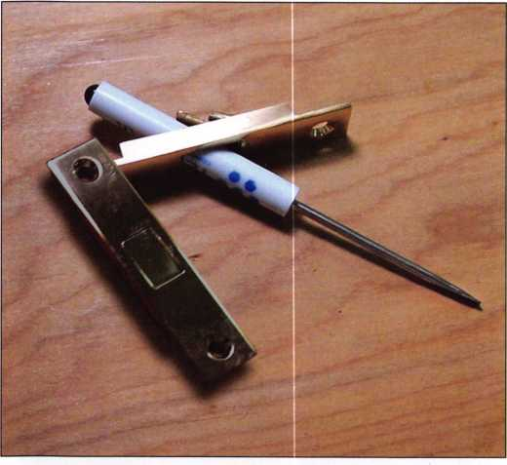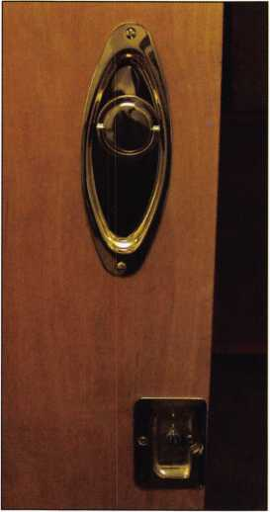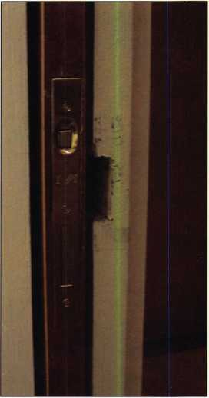

Photo 10 Photo 11

Photo 12

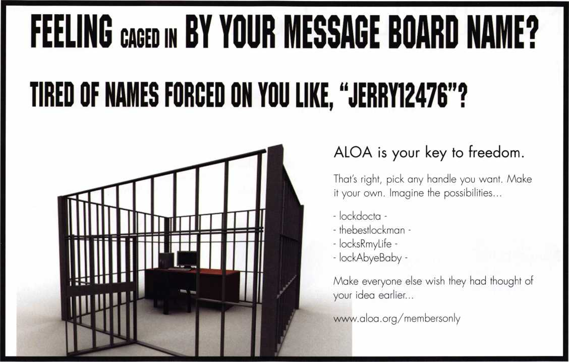

**THE HINGE DOCTOR**

**by GKL Products**

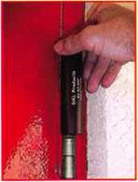

**HA1 For  
Standard**

**Commercial**

**4-1/2" x 4-1/2'**

**Butt Hinges**

**HA2**

***"The HULK"***

**For Residential Hinges**

**COMING IN ha3  
SEPTEMBER For Ball-**

**Bearing**

**Commercial Hinges**

**The Hinge Doctor is a great way to repair those sagging metal  
doors. Slip the tool over the hinge and open the door an inch**

**or two past the point where the tool binds against the**

**hinge, remove the tool and check the door,  
which should now be working properly.**

**If you're a locksmith these tools  
will turn a profit the 1st time you  
use them!  
Uses - schools, hospitals,**

**commercial buildings, storefronts  
with butt hinges, office doors, new**

**construction, door alignment, sagging**

**doors, jail cells, anywhere there are  
commercial grade hinges.**

**HA4**

**For Prison**

**& Institutional**

**Hinges &**

**Spring Hinges**

US Patent **#6450003**

**[www.hingedoctor.com](http://www.hingedoctor.com)**

800-924-5397

Over

**10,000**

Satisfied

Customers

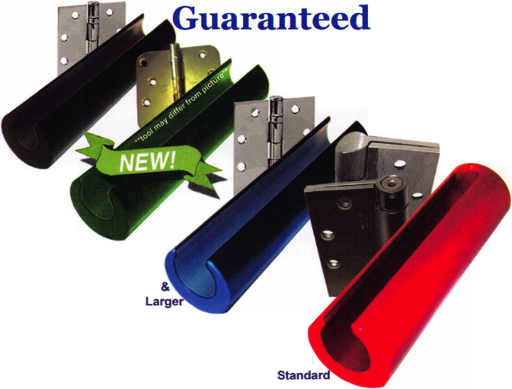

New Products from Master Lock

by Roxanne Piagentini and Billy B. Edwards, Jr.

As with most companies the only real way to increase your business is to develop new products. Master Lock Co. is best known for being a provider of portable security and as part of that security has traditionally offered products associated with towing and trailers. The 30 series trailer coupler locks have been popular for years but there has always been a complaint when it came to rekeying them. Master has recently redesigned that series to make it easily rekeyable. It now has in it a Python style cylinder that can be rekeyed using the 8491 Python rekeying kit. To make the new version easily recognizable, the color of the lock body has also been changed from brown to a dark gray.

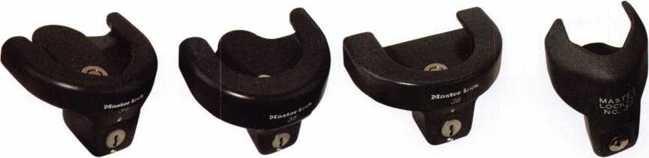

Another lock available for a trailer coupler latch is the 377. Not easily rekeyable, it is supplied with the popular number 1 keyway which means standard laminated padlocks can be ordered to a corresponding key code.

Known for an innovative approach when producing new products, Master Lock has ventured into non-locking areas related to tow­ing equipment. This total-system approach guarantees a means for locking each and every component the end user needs to protect.

Multi-fit Hitches

When designing a complete system for towing Master Lock started with the basics and built from there. You cant get much more basic than the hitch itself and Master Lock offers two multi-fit versions. Hardware and instructions are included for easy installation. No special tools are required and many applications do not require drilling. All hitches exceed V-5/J684 specifications.

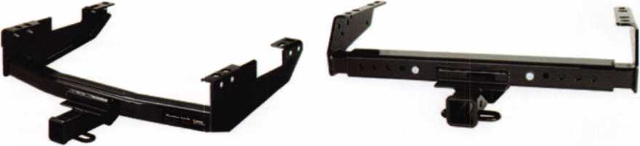

Once the hitch is mounted on the vehicle, the security options become more defined. The ball mount receivers on hitches are the first security concern. Typically supplied with a pin and a clip retainer, the clip will invariably be lost when ball mounts are changed. The end user will then typically resort to using a piece of wire in place of the clip which is dangerous. To solve that issue, Master Lock has developed a pin with a built-in lock that won’t be lost.

**30**

Keynotes • February 2005

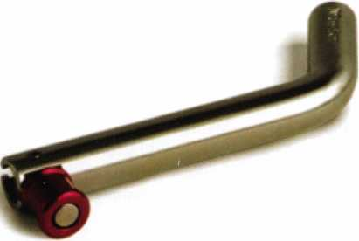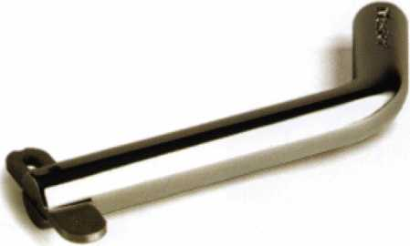

Pivot-Lock™ Receiver Hitch Pins

The 1465 is a 5/8” diameter pin that has a red spring-loaded cap on it. The cap can be moved to a locked position. The version with the flat slide is available in two diameters. The pivoting anodized aluminum barrel of the 1465 is attached to a stainless steel hitch pin and the pivoting blade on the chrome plated hitch pin can be locked in both directions with a one-handed operation.

Receiver Locks

If you want a key-operated hitch pin Master Locks receiver locks feature a Weather Tough™ seal and water-tight cap in addition to the solid-brass lock cylinder and cylinder case providing extreme corrosion resistance. These multi-fit receiver locks have a unique revolving stainless-steel sleeve that resists cutting and sawing and fit multiple applications.

Ball Mounts

Master Lock also offers a range of ball mounts. The rise and drop information is printed on the face of each ball mount.

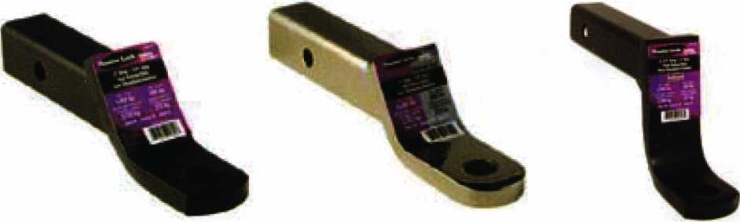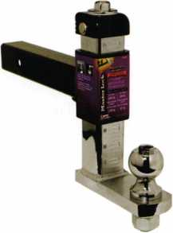

A Level Trailer Equals Safer Towing!

Standard ball mounts are limited to a single fixed position and almost always result in an un-  
level trailer. In addition, some people have different trailers with different heights that they  
periodically tow with the same vehicle. Until now, the easiest way to keep a trailer level was  
having a different ball mount for each one. Master Lock has a new solution and has invented  
the World’s First Adjustable Height Zero Tilt Ball Mount so a perfect leveling can be achieved.  
This product is effortlessly adjusted from a 7-3/4” drop to a 6-1/4” rise and adjusts while the  
trailer is loaded on the ball mount. Its E-Z-Adjust feature allows the ball mount to be raised or  
lowered by using a 7/8” wrench or a 3/8” square ratchet drive. The ball mount height is auto-  
matically retained by a patented spring clip feature. It fits: 2” X 2” receivers with a trailer  
weight capacity of 5,000 lbs and a tongue weight capacity of 500 lbs.

Popular Mechanic’s Magazine, Editor’s Choice Award Winner!

Keynotes • February 2005

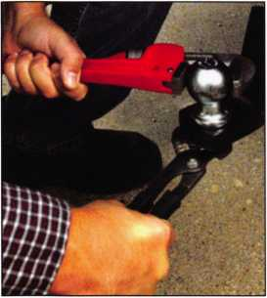

Hitch Ball Installation Made E-Z!

The design of standard, flat-topped hitch balls has not changed for decades. When the nut is  
torqued onto the hitch ball shank, the ball rotates preventing a properly torqued installation,  
needed for safe towing. To try and keep the ball from spinning, most folks use a pipe wrench or  
pliers, often damaging the chrome finish and inviting rust.

With a convenient hex-drive top on Master Locks E-Z Mount Hitch Ball,  
the 1-7/8” and 2” diameter balls can now be held securely without damag-  
ing the chrome finish. In addition, the dome-shaped hex-drive fills out the  
trailer’s coupler cavity ensuring a secure fit and resulting in less rattle  
between ball and coupler.

Another problem area is that of ball theft. Thieves can dismount the ball  
with a trailer attached and still be able to steal the trailer. Master Lock has  
created a way to stop this type of theft.

New Layer in Trailer Security!

Master Lock’s new Hitch Ball Lock, combined with the E-Z Mount Hitch  
Ball, addresses that vulnerable area of trailer theft. Even when a receiver  
lock and coupler latch lock are used, a thief can still steal a trailer by simply  
removing the nut on the hitch ball and pulling the coupler and hitch ball  
out of the ball mount. With Master Lock’s hitch ball lock securely in place;  
thieves will be discouraged, since the lock is designed to obstruct access to  
the hitch ball hex nut.

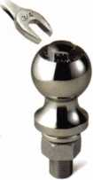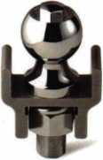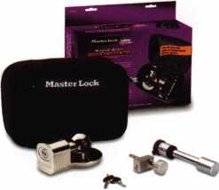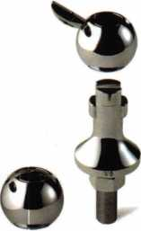

Typically, as encountered all to often in the real world, the solution to one  
problem creates another problem. Many people have different trailers that  
require a different size ball for the coupler. That means they must either  
have multiple mounts for the different size balls or they are continually  
changing the balls on a mount...time for another innovation!

Interchangeable Hitch Balls!

Master Lock’s new, easy to use, Interchangeable Hitch Ball makes it easy to  
switch from a 1-7/8” ball to a 2” ball, with just a flip of its pocket-knife  
style blade and a quarter-turn of the ball. Its retention blades are perma-  
nently attached so there are no small parts to lose. This unique patented  
design is guaranteed to work in the toughest road conditions.

Keyed Alike Trailer Lock Set!

Multiple trailer ownership has created the need for a selection of different types of lock keyed  
alike. In the 3774 kit, the receiver lock has a Weather Tough™ seal and watertight cap for  
extreme weather protection. Its removable stainless steel sleeve fits various diameter receiver holes.  
The adjustable coupler latch lock fits 5/8”, 1”, and 2” coupler holes and the universal coupler  
lock fits most 1-7/8”, 2”, and 2 5/16” couplers. The same key fits all three locks.

Safety Cables!

To complete the towing system, Masterlock also offers self-coiling safety cables which reduce the chance of dragging. The 40” cables have a vinyl coating that protects the cable from corrosion as well as the finish on the vehicles being towed.

You can find all of these products on pages 50—60 of the current Masterlock catalog. Contact your distributor for a copy of the cata­log and pricing information.

**32**

Keynotes • February 2005

IN THE WAR ON CRIME, YOU DON'T NEED A PADLOC YOU NEED AN ARSENAL.

You’re constantly fighting crime on many fronts. That’s why we manufacture a complete line of commercial padlocks, each one tough enough to be called a Master Lock. It’s the name trusted the world over for quality padlock security. Whether you’re battling theft, unauthorized entry or the elements, we can arm you with a solid solution for any industrial application, even safety lockout. So make our commercial line your itfl

first line of defense. For more information, contact your local

distributor, or call 1-800-308-9244.

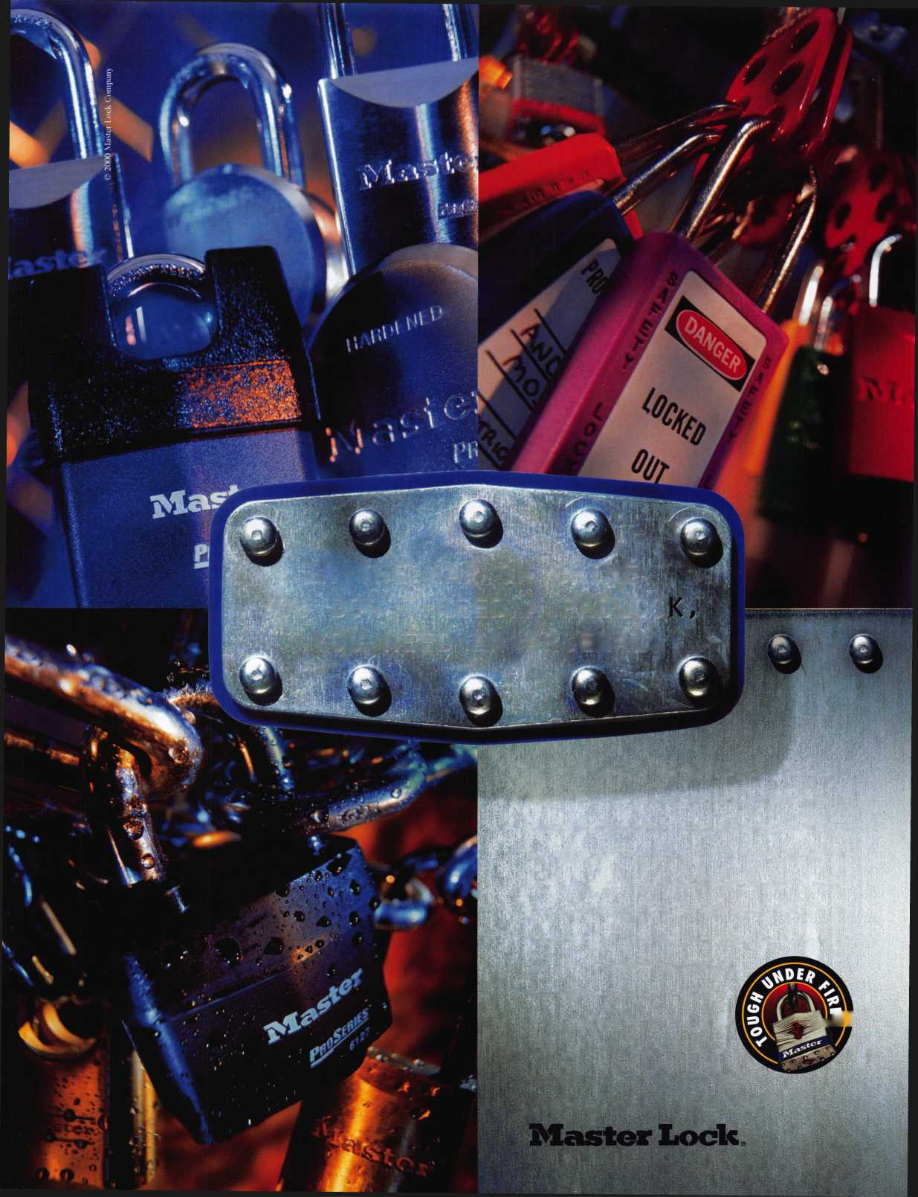

Why Leasing Pays

by Joseph Finelli



Why leasing pays

In todays increasingly competitive marketplace, more and more companies are integrating leasing into their sales process. It is becoming easier and easier to sell additional CCTV’s and DVR’s by simply offering your customers a financing alternative. Think about it. How many times have you lost a job because of cost? Maybe the customer did not have the cash or their budget would not allow them to make a one time cost allocation to acquire your system. Offering a leasing plan makes the sale easier. Instead of a four camera system with DVR systems costing the cus­tomer $4,500, it now only costs them $112 per month. And by offering a lease payment, you enable your customer to match the monthly savings he will realize through shrinkage reduction to the monthly cost of the equipment. You can also cost justify additional equipment that the cus­tomer might have simply considered too expensive if he was paying cash. This is especially important to the small busi­ness owner who typically needs to conserve cash for his core

business operations. Leasing is a powerful selling tool that the dealers in the security industry are using to close more sales. If you’re not offering it, you’re probably putting your­self at a competitive disadvantage.

Here’s how it works:

Use a simple multiplier to get a monthly payment and offer it to the customer. When the customer agrees to lease, send them an application and return it to your account representative at Marlin Leasing. Once the cus­tomer is approved, we take over from there. We contact the customer, get the paperwork signed and issue you a purchase order. This gives you the green light to order, ship, and install the system knowing the customer has signed the lease contract. Once the system is installed and the final paperwork is completed, you get paid 100% of the job cost and we enter into a monthly payment arrange­ment with the customer. There is no recourse back to you.

Keynotes • February 2005

Why offer leasing?

Total Project Financing

As a security consultant, you can’t offer your customer the total solution if they can’t afford it. By offering a financing alternative you can provide a complete security solution and the means to acquire it through financing. You are helping your customer understand the cost and savings on a monthly basis, which is probably how they already look at their cash flow.

Leasing can also help to enhance your profit margins. Customers are a lot less likely to haggle over a monthly payment than a total job cost. Reducing a total job cost devalues the product and the service. Leasing circumvents this process and adds further value by making the entire job more affordable and doesn’t diminish the quality of the product through price erosion. This also provides a good opportunity to up sell customers. Example: A few addi­tional cameras may now only cost an additional $20 per month as opposed to an additional $ 1,000 that the cus­tomer would normally pay up front.

Customers who choose to lease are more likely to do it again in the future. Leasing provides an excellent opportu­nity to upgrade the customer as their lease begins to mature. In some instances you can provide the customer with an entirely new system for the same monthly pay­ment that they have become conditioned to making each month. This makes for a new sale for the vendor and new state of the art equipment and seamless transition for the customer.

Why Marlin Leasing?

Documentation usually consists of a one page application and a one page lease agreement. Marlin Leasing will inter­face directly with the customer and handle all the paper­work. Documents are faxable so you can even get paid the same day the installation is complete if all the paperwork is legible and correct.

You don’t have to be a financing expert to offer leasing.

By partnering with Marlin Leasing, you will work with an experienced account manager who can guide you and the customer through the lease transaction. At Marlin Leasing, we specialize in working with small business own­ers both as vendor partners and lease customers.

This program enables you to include the product cost, installation and delivery as well as other costs associated with the project rolled into one monthly payment. Certain restrictions may apply. Contact your Marlin representative for guidelines.

**n MARLIN LEASING**

***...your business equipment basing partners.***

January 20,2005

This quote has

been prepared for: Lessee Name Valid through: April 20,2005 Vendor: Vendor Name Sales Rep: Sales Rep Phone: Phone

System: Brief Equipment Description

|  |  |  |
| --- | --- | --- |
| SHRINKAGE ANALYSIS | LEASE SAVINGS ANALYSIS | |
| Monthly Shrinkage: $1,000 | # of Years | Yearly Savings |
| % Recouped with System: 70% | l | $6,091 |
| $ Saved per Month: $700 | 2 | $6,091 |
|  | 3 | $6,091 |
| System Cost: $8,000.00 | 4 | S6,091 |
| Lease Term: 60 Months | 5 | $6,091 |
| Monthly Lease Payment: | $192.40 | |  |  |
|  |  |  |
| Net Monthly Savings: $508  Net Yearly Savings: $6,091  Security Deposit: 2 Paymcnt(s) Purchase Option : $1.00 Buy-Out |  |  |

Estimated payments shown are for companies In business 2 years or more. Documentation fee up to $190 required. For transactions over $50,009. please call for special rates. Rates effective through March 31,2005.

Please note: Payments shown are subject to state and local taxes. Consult your tax advisor for more information. Subject to Marlin's credit approval and receipt of required documents.

MLCQ70

Northeastern Division

300 Fellowship Rood Mount Laurel, NJ 08054 888 479.9111, fa,. 888 479 1100 [www.maflinleojin0.com](http://www.maflinleojin0.com)

Shrinkage/Shoplifting Calculator

As an industry leader in security leasing, Marlin has devel­oped a Shrinkage or Shoplifting Calculator. The calculator is an Excel based tool that helps customers to visualize the cost savings that leasing a security system can provide today. This tool helps your customers to quantify how much they are losing each month through employee theft while cross referencing that with a monthly lease payment to show monthly and yearly cost savings they would have by leasing your system. Essentially, it is an ROI calculator that will help your customers become more comfortable with their system purchase.

If you would like to learn more about these programs con­tact Mark Ainsley at (888) 479-9111, ext 4175.

Keynotes • February 2005

**35**

Classifieds



EMPLOYMENT

IN-HOUSE LOCKSMITH POSITION NEEDED

New York Licensed Locksmith with 25 + years exp. in running and maintaining an In-house Locksmith shop. Experienced in Masterkeying, Removable core systems, Simplex com­bination locks, Lock-Alarm hardware, desk and cabinet hardware, door- closers, etc. Member of ALOA & Nyail (NY Assoc. In-house Locksmiths). Available immediately. Resume upon request. Call or Email Richard Sommers at (914) 734-2303 [Bestkey@Optonline.net](mailto:Bestkey@Optonline.net).

LOCKSMITH TECHNICIAN WANTED

In-house locksmith with experience road and shop work for commercial, safe, and access control service.

Salary plus benefits. See website or call for details 71 3-755-5906 for details. Apply in-person 1310 Prairie 2nd floor, Houston, Texas, 77002

<http://www.co.harris.tx.us/hrrm/Empl>

oyment.htm

NOTICES

2005

EAST COAST REGIONAL LOCK & SECURITY SHOW (CLASSES, TRADE SHOW,

AND BANQUET)

March 3rd thru March 6th Crowne Plaza Meadowlands Hotel 2 Harmon Plaza Secacus, NJ

For More Information:

PO Box 2441

Morristown, NJ 07962-2441 Fax 973-538-1588 Or visit our web site at [www.mlanj.org](http://www.mlanj.org)

THE OKLAHOMA MASTER LOCKSMITHS ASSOCIATION'S ANNUAL DISTRIBUTORS SHOW

February 5, 2005, 9a.m. - 5p.m. at the Holiday Inn Select, Tulsa, Oklahoma. Sponsored by IDN and Acme. Please call Mike McGrew at 918-333-9136 for more information.

WANTED TO BUY/SELL

EQUIPMENT FOR SALE

Various old locksets (e.g., deadbolts with TT" throws) and especially old out-of-production key blanks, sectional or otherwise (such as the Yale &

Towne "Omega" offset "X" and "Z" series & the Corbin "R" series bit keys). Also of note is a behemoth llco bit & barrel duplicating machine where the double-jaw, single tower can be rotated to make ward cuts & an R.C. Allen pull handle tabulating cash register. Time is of the essence as my building will be torn down in a month and most of this old stock will not be moving with me unless it is spo- kenfor. I would also be interested in hearing from anyone who could pick up & provide at least a temporary home for these old soldiers before they're buried under tons of rubble. Any inquiries or "wish lists" can be sent to me, Tom Steger, at [lockdoc215@hotmail.com](mailto:lockdoc215@hotmail.com).

Classified Advertising Policy

Classified advertising space is provided free of charge to ALOA members and for a fee of $2.00 per word, $40.00 mini­mum for non members. Classified ads may be used to advertise used merchandise and overstocked items for sale, "wanted to buy" items, business opportunities, employment opportunities/positions wanted and the like. Members or non members wishing to advertise services or new merchandise for sale may purchase a "Commercial Classified Ad" for a fee of $4.00 per word with a minimum of $ 100.00. Each ad will run for two issues. For blind boxes there is a $10.00 charge for mem­bers and non members. All ads must be submitted in writing to the Advertising Sales Department via fax at 817-645-7599 or through an email to [adsales@aloa.org](mailto:adsales@aloa.org) by the fifteenth of the month two months prior to issue date. ALOA reserves the right to refuse any classified advertisement that it deems inappropriate according to the stated purpose of the classified advertising section.

EQUIPMENT FOR SALE

Mounted Locknetic Sample For Sale: CM5190- MGKx626 mounted on a oak mount asking $100 Primus Demo Kit[/b] New asking $75.00 [kishjohn@comcast.net](mailto:kishjohn@comcast.net) Telephone is 412-400-5900

EQUIPMENT FOR SALE

Intellikey items many 1000 and 4000 series items: keys, sales kits much more.Stanley prime painted hinges, CB,F series many sizes If interested please email me at [ARCHHDW@YAHOO.COM](mailto:ARCHHDW@YAHOO.COM)

WELL ESTABLISHED

Key and Lock business. Good return on investment. $275,000. Call Mark Gillispie at 503-812-2615.

BUSINESS FOR SALE

Only locksmith in the county, five years of growing sales. Van, tools, codes machines, and inventory. Reasonably priced. ALOA member. Located in NW Ohio. Call 419-232-4404 or email locksmith45891 @yahoo.com

GREAT OPPORTUNITY TO OWN

Busy store established in 1977, three trucks on the go all day. Great climate to work in, 40 miles north of San Diego. Owner retiring. Business needs energetic, experienced person for good cus­tomers. Call 760-801-9351 for info regarding sales and asking price.

WHOLESALE SAFE DEPOSIT LOCKS

Diebold, Herring Hall Marvin, llco, LeFebure, Mosler, Precision, S&G, Security Corp, Yale. Now available Safe Deposit Boxes Sections, Doors, Hinges and Bond Tins. Vault Doors, Safes, Night Depositories, Vault Lockers and One Inch Plate Steel are also stocked items. Call WBI (954)484- 2404 or [Sales@WBI.US](mailto:Sales@WBI.US).

FOR SALE

Key Blanks: Original Yale, Hurd, replacement Independent, Graham, Keil, misc. mfg. For a list or to specify your needs email or write: [c- cameron@triad.rr.com](mailto:c-cameron@triad.rr.com), Charles Cameron, CML, 2818 Sherwood St., Greensboro, NC 27403.

Robert D Colbert

New Castle, PA

***COtfQKA TULA TtOtfSf***

$ ***mm***

**SI.** Tellefson

Seattle, WA

PANASONIC

►LASMATV

ITL KEY MACHINE

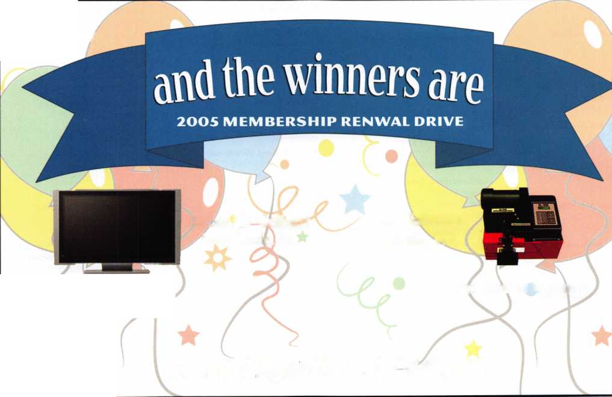

Distributor

**1 st In Hardware, Inc.**

Phone: 866-397-9900  
Fax: 866-646-0045  
www. 1 stinhardware.com

**ADI Inc.**

Phone: 631-692-1000  
Fax: 631-692-3011

**Accredited Lock Supply Co.**

Phone: 800-652-2835  
Fax: 201-865-0030  
[www.acclock.com](http://www.acclock.com)

**Ace Lock & Security Supply**

Phone: 800-223-5625 Fax: 908-688-2442 [www.acelock.com](http://www.acelock.com)

**Andrews Wholesale Lock Supply**

Phone: 717-272-7422 Fax: 717-274-8659 [www.andrewslock.com](http://www.andrewslock.com)

**Boyle & Chase Inc.**

Phone: 800-325-2530 Fax: 800-205-3500 [www.boyleandchase.com](http://www.boyleandchase.com)

**Chinrose International**

Phone: 503-357-7553 Fax: 503-357-5522 [www.chinrose.com](http://www.chinrose.com)

**Clark Security Products**

Phone: 888-784-131 1 Fax: 619-718-7333 [www.clarksecurity.com](http://www.clarksecurity.com)

**Cook's Building Specialties**

Phone: 505-883-5701 Fax: 505-883-5704

**Dire's Lock & Key Company**

Phone: 303-294-0176 Fax: 303-294-0198

**Direct Security Supply; Inc.**

Phone: 800-252-5757 Fax: 800-452-8600

**Discount Key Machines.Com/Busch**

Phone: 800-332-8724 Fax: 407-363-4666

**Doyle Security Products**

Phone: 800-333-6953 Fax: 612-521-0166 [www.doylesecurity.com](http://www.doylesecurity.com)

**Dugmore and Duncan, Inc.**

Phone: 888-384-6673 Fax: 888-329-3846

|  |  |  |  |  |
| --- | --- | --- | --- | --- |
| W a | s s o  mem | c  b | (D | a t e  r s |
| E. L. Reinhardt Co., Inc. | M. Zion Company |  |  | Turn 10 Wholesale |
| Phone: 800-328-1311 | Phone: 212-349-8677 |  |  | Phone: 800-848-9790 |
| Fax: 651-481-0166 | Fax: 212-964-0495 |  |  | Fax: 800-391-4553 |
| [www.elreinhardt.com](http://www.elreinhardt.com) | [www.mzion.com](http://www.mzion.com) |  |  | U.S. Lock Corp. |
| Ewert Wholesale Hardware | McDonald Dash Locksmith Supply | | | Phone: 800-925-5000 |
| Phone: 800-451-0200 | Phone: 800-23 8-7541 |  |  | Fax: 800-338-5625 |
| Fax: 708-597-0881 | Fax: 901-366-0005 |  |  | [www.uslock.com](http://www.uslock.com) |
| Fairway Supply, Inc. | [www.mcdonalddash.com](http://www.mcdonalddash.com) | |  | Wilson Safe Company |
| Phone: 214-350-0021 | Monaco Lock Co. |  |  | Phone: 215-492-7100 |
| Fax: 214-352-4299 | Phone: 800-526-6094 |  |  | Fax: 215-492-7104 |
| [www.fairwaysupply.com](http://www.fairwaysupply.com) | Fax: 800-845-5625 |  |  | [www.wilsonsafe.com](http://www.wilsonsafe.com) |
| Foley-Belsaw Company | [www.monacolock.com](http://www.monacolock.com) |  |  |  |

Phone: 800-821-3452 Fax: 816-483-5010 [www.foley-belsaw.com](http://www.foley-belsaw.com)

**Fried Brothers Inc.**

Phone: 800-523-2924 Fax: 215-592-1255 [www.fbisecurity.com](http://www.fbisecurity.com)

**Hans Johnsen Company**

Phone: 214-879-1550 Fax: 214-879-1530

**Hardware Agencies, Ltd.**

Phone: 416-462-1921 [www.hardwareagencies.com](http://www.hardwareagencies.com)

**IDN Incorporated**

Phone: 817-421-5470 Fax: 817-421-5468 [www.idn-inc.com](http://www.idn-inc.com)

**Intermountain Lock & Supply**

Phone: 800-453-5386 Fax: 801-485-7205 [www.intermountainlock.com](http://www.intermountainlock.com)

**International Electronics, Inc**

Phone: 800-343-9502 Fax: 617-821-4443

**Jo Van Distributors**

Phone: 416-752-7249

Fax:416-752-7282

[www.jovanlock.com](http://www.jovanlock.com)

**Lockmasters, Inc.**

Phone: 859-885-6041 Fax: 859-885-7093 [www.lockmasters.com](http://www.lockmasters.com)

**Locks Company**

Phone: 800-288-0801 Fax: 305-949-3619

**Locksmith Ledger International**

Phone: 770-886-0800 Fax: 770-889-7703 [www.lledger.com](http://www.lledger.com)

**Omaha Wholesale Hardware**

Phone: 800-238-4566 Fax: 402-444-1664 [www.omahawh.com](http://www.omahawh.com)

**RA-Lock Company**

Phone: 972-775-6301 Fax: 972-775-6316 [www.ralock.com](http://www.ralock.com)

**Security Distributors Inc**

Phone: 800-333-6953 Fax: 612-524-0166

**Security House**

Phone: 905-669-5300 Fax: 905-660-6313 [www.securityhouselock.com](http://www.securityhouselock.com)

**Security Lock Distributors**

Phone: 800-847-5625

Fax: 800-878-6400

[www.securitylockdistributors.com](http://www.securitylockdistributors.com)

**Shin-An Enterprise Inc.**

Phone: 718-225-5380 Fax: 718-819-0723

**Southern Lock and Supply Co.**

Phone: 727-541-5536 Fax: 727-544-8278 [www.southernlock.com](http://www.southernlock.com)

**Stone & Berg Wholesale**

Phone: 800-225-7405 Fax: 800-535-5625

**The Locksmith Store Inc.**

Phone: 847-364-51 1 1 Fax: 847-364-5125 [www.locksmithstore.com](http://www.locksmithstore.com)

**Timemaster Inc.**

Phone: 859-259-1 878 Fax: 859-255-0298 [www.time-master.com](http://www.time-master.com)

**Top Notch Distributors, Inc.**

Phone: 800-233-4210 Fax: 800-854-4146 [www.topnotch.bz](http://www.topnotch.bz)

Manufacturer

**A & B Safe Corporation**

Phone: 800-253-1267 Fax: 856-863-1208 [www.a-bsafecorp.com](http://www.a-bsafecorp.com)

**ABUS Lock Company**

Phone: 800-352-2287 Fax: 602-516-9934 [www.abus.com](http://www.abus.com)

**Access Security Products Ltd.**

Phone: 905-337-7874 Fax: 905-337-7873 [www.access-safe.com](http://www.access-safe.com)

**Adams Rite Mfg Company**

Phone: 800-872-3267 Fax: 800-232-7329 [www.adamsrite.com](http://www.adamsrite.com)

**Adesco Safe Mfg. Company**

Phone: 800-694-9340 Fax: 562-408-6427 [www.adesco.com](http://www.adesco.com)

**Adrian Steel Company**

Phone: 800-677-2726 Fax: 517-265-5834 [www.adriansteel.com](http://www.adriansteel.com)

**All Five Tool Company, Inc.**

Phone: 860-583-1691 Fax: 860-583-4516 [www.all5tool](http://www.all5tool) .com

**American Lock Company**

Phone: 708-534-2000 Fax: 708-534-0531 [www.armericanlock.com](http://www.armericanlock.com)

**American Security Products**

Phone: 909-685-9680X1083 Fax: 909-685-9685 [www.amsecusa.com](http://www.amsecusa.com)

**Best Metaline Inc.**

Phone: 714-441-0098 Fax: 714-441-0977



**Bianchi USA, Inc.**

Phone: 800-891-2118 Fax: 216-803-0202

**Buddy Products**

Phone: 800-886-8688 Fax: 312-733-8356 [www.buddyproducts.com](http://www.buddyproducts.com)

**CCL Security Products**

Phone: 800-733-8588 Fax: 847-537-1800

**COMPX Security Products**

Phone: 864-297-6655 Fax: 864-297-9987 [www.compxnet.com](http://www.compxnet.com)

**D&D Technologies (USA), Inc.**

Phone: 714-677-1300X292 Fax: 714-677-1299 [www.ddtechusa.com](http://www.ddtechusa.com)

**DETEX Corp.**

Phone: 800-729-3839 Fax: 830-620-6711 [www.detex.com](http://www.detex.com)

**DORMA Architectural Hardware**

Phone: 717-336-3881 Fax: 717-336-2106 [www.dorma-usa.com](http://www.dorma-usa.com)

**Datakey Electronics**

Phone: 952-746-4066 Fax: 866-289-4212 [www.datakeyelectronics.com](http://www.datakeyelectronics.com)

**Don-Jo Manufacturing, Inc.**

Phone: 978-422-3213 Fax: 978-422-3467 [www.don-jo.com](http://www.don-jo.com)

**Door Controls International**

Phone: 800-742-3634 Fax: 800-742-0410 [www.doorcontrols.com](http://www.doorcontrols.com)

**ESP Lock Products Inc.**

Phone: 800-434-8960 Fax: 978-562-9859

**FireKing Security Products**

Phone: 800-457-2424 Fax: 800-896-6606 [www.fkisecuritygroup.com](http://www.fkisecuritygroup.com)

**Framon Manufacturing Company Inc.**

Phone: 989-354-5623 Fax: 989-354-4238 [www.framon.com](http://www.framon.com)

**HPC, Inc.**

Phone: 847-671-6280 Fax: 847-671-6343 [www.hpcworld.com](http://www.hpcworld.com)

**HY-KO Products Co.**

Phone: 330-467-7446 Fax: 330-467-7442

**Hammerhead Industries, Inc.**

Phone: 805-658-9922 Fax: 805-658-8833 [www.gearkeeper.com](http://www.gearkeeper.com)

**Ingersoll Rand SSA**

Phone: 317-613-8025 Fax: 317-613-8068 [www.schlagelock.com](http://www.schlagelock.com)

**Jet Hardware Mfg., Co.**

Phone: 718-257-9600 Fax: 718-257-0973 [www.jetkeys.com](http://www.jetkeys.com)

**KABA ILCO Corp.**

Phone: 252-446-3321 Fax: 252-446-4702 [www.kaba-ilco.com](http://www.kaba-ilco.com)

**KEY-BAK/West Coast Chain Mfg.**

Phone: 909-923-7800 Fax: 909-923-0024 [www.keybak.com](http://www.keybak.com)

**Keri Systems Inc.**

Phone: 408-451-2520 Fax: 408-441-0309 [www.kerisys.com](http://www.kerisys.com)

**Knaack Manufacturing Co.**

Phone: 800-456-7865 Fax: 815-459-9097 [www.weatherguard.com](http://www.weatherguard.com)

**LAB Security**

Phone: 800-243-8242 Fax: 860-583-7838 [www.labpins.com](http://www.labpins.com)

**La Gard Inc.**

Phone: 310-325-5670 Fax: 310-325-5615 [www.lagard.com](http://www.lagard.com)

**Lock America, Inc. dba L.A.I. Group**

Phone: 714-373-2993 Fax: 714-373-2998 [www.laigroup.com](http://www.laigroup.com)

**Lucky Line Products, Inc.**

Phone: 858-549-6699 Fax: 858-549-3241 [www.luckyline.com](http://www.luckyline.com)

**M.A.G. Security**

Phone: 714-891-5100 Fax: 714-892-6845 [www.magsecurity.com](http://www.magsecurity.com)

**MUL-T-LOCK USA, Inc.**

Phone: 800-562-3511 Fax: 973-778-4007 [www.mul-t-lock.com](http://www.mul-t-lock.com)

**Medeco Security Locks**

Phone: 540-380-5000 Fax: 540-380-5010 [www.medeco.com](http://www.medeco.com)

**ROFU International Corp.**

Phone: 253-922-1828 Fax: 253-922-1728 [www.rofu.com](http://www.rofu.com)

**Rutherford Controls Int'l Co.**

Phone: 757-427-1230 Fax: 757-427-9549 [www.rutherfordcontrols.com](http://www.rutherfordcontrols.com)

**STRATTEC Security Corp.**

Phone: 414-247-3415 Fax: 414-247-3692 [www.strattec.com](http://www.strattec.com)

**Sargent & Greenleaf, Inc.**

Phone: 800-826-7652X201 Fax: 859-885-3063 [www.sargentandgreenleaf.com](http://www.sargentandgreenleaf.com)

**Sargent Manufacturing Co.**

Phone: 800-727-5477 Fax: 888-863-5054 [www.sargentlock.com](http://www.sargentlock.com)

**Schwab Corp.**

Phone: 765-447-9470 Fax: 765-447-8278 www. schwa bcor p. com

**Securitron Magnalock Corp.**

Phone: 775-355-5625 Fax: 775-355-5636 [www.securitron.com](http://www.securitron.com)

**Security Door Controls**

Phone: 805-494-0622 Fax: 805-494-8861 [www.sdcsecurity.com](http://www.sdcsecurity.com)

**Security Solutions**

Phone: 405-376-1600 Fax: 405-376-6870 [www.securitysolutions-usa.com](http://www.securitysolutions-usa.com)

**Townsteel, Inc.**

Phone: 626-858-5080 Fax: 626-858-3393 [www.townsteel.com](http://www.townsteel.com)

**Trine Access Technology**

Phone: 718-829-2332 Fax: 718-829-6405 [www.trineonline.com](http://www.trineonline.com)

**Victor E-lok, Inc.**

Phone: 949-916-1200 Fax: 949-916-1300 [www.victorelok.com](http://www.victorelok.com)

**Videx Inc.**

Phone: 541-758-0521 Fax: 541-752-5285 [www.videx.com](http://www.videx.com)

**YSG Door**

**Security Consultants, Inc.**

Phone: 800-438-1951 Fax: 800-338-0965

Service

Organization

**Allstate Insurance Company**

Phone: 800-859-0247 Fax: 847-326-7509 [www.allstate.com](http://www.allstate.com)

**Cross Country Automotive Services**

Phone: 800-541-2262 Fax: 781-393-0256 [www.argosi.com](http://www.argosi.com)

**Massglass & Door Service**

Phone: 888-742-8837 Fax: 805-497-2255 [www.massglass.com](http://www.massglass.com)

**Webster Safe & Lock Co., Inc.**

Phone: 901-332-2911 Fax: 901-332-2878 [www.webstersinc.com](http://www.webstersinc.com)



US Congress & State Houses Reconvene:

The 109th Congress convened in January and began swearing in new members and reorganizing committees. There were some confirmation hearings in the Senate for cabinet appointees, but otherwise there was very little substantive work by Congress until after the Presidential Inauguration on January 20.

Currently, there are 37 State Houses in session, with more returning every week. I am carefully tracking all new legislation as the State Houses reconvene. Recently, I attended legislative functions in South Carolina and received initial support in efforts to get a licensing bill passed there. Indiana has introduced a "registration" bill that will include background checks. I am working hard to incorporate ALOA's "Model Law" into the process.

Motor Vehicle Right to Repair:

With the new year, comes new hope of attaining lock­smiths' automotive repair goals. ALOA's partner, The Coalition for Auto Repair Equality (C.A.R.E) is once again planning on introducing legislation aimed at forc­ing OEM's to release the information necessary to return a car to driveability. With over one hundred co-sponsors in the House last year and over a dozen in the Senate, the prospects for passage this year look quite good.

ALOA is also well aware of the situation with General Motors vehicles and the Cross Country Motor Service.

The recently increased difficulty in obtaining key codes is unacceptable and possible solutions are being explored here in ALOA's Dallas headquarters.

FCC Fax Regulations:

ALOA's Fax Ban Coalition met late last week. There were strategy discussions aimed at making the 109th Congress pass legislation that would overturn the pend­ing regulations issued by the Federal Communications Commission (FCC) governing commercial faxes. The FCC's proposed regulations have been stayed until July 1, 2005, which will hopefully provide sufficient time to work with both the Senate and the House to pass correc­tive legislation.

These regulations could drastically effect the ways in which locksmiths use faxes to solicit new business.

Before convening last year, legislation did pass both the House (H.R. 4600) and Senate (S. 2603) that would restore the "established business relationship" (EBR) exception for sending commercial faxes. Unfortunately, due to non-germane attachments to the Senate version of the bill, final legislation was not enacted.

ALOA and the coalition have continued to work closely with House and Senate staff to discuss the best and quickest means in which to get this legislation introduced and passed early in the 109th Congress.

Best Regards,

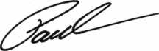

Paul M. Kanitra



Keynotes • February 2005

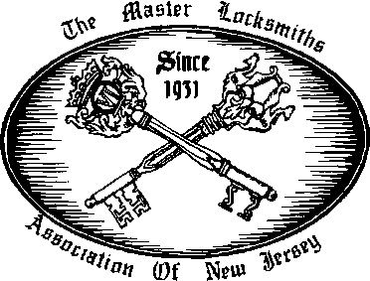

2005

East Coast Regional  
Lock & Security Show  
(Classes, Trade Show, and Banquet)

March 3rd thru March 6th  
Crowne Plaza Meadowlands Hotel  
2 Harmon Drive  
Secaucus, NJ 07094

For More Information:

PO Box 2441

Morristown, NJ 07962-2441  
Fax 973-538-1588  
Or visit our web site at  
[www.MLANJ.org](http://www.MLANJ.org)

Buyer's Marketplace

IN-STOCK...MORE SAFES

***FREE Freight Program***

***(30 States)***

AMSEC FireKing

**Qariall hayman meilink y/cron**

TURfl lO

**WHOLESALE SERVICE**

800-848-9790



**SAFI CORPORATION**

MANUFACTURES OF QUAUTY DEPOSITORY SAFES AND CHESTS

DISTRIBUTING FROM WAREHOUSES IN

* LOS ANGLES, CA
* CHICAGO, IL
* GLASSBORO, NJ

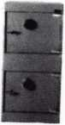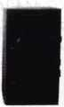

AB-4-30-3S AB-9-2 WS 10-2

Chose from over 75 models in slock

A & B is now a stocking distributor

for Mutual Safes

We ship your order within

24 hours

See us

*at* [www.a-bsafecorp.com](http://www.a-bsafecorp.com) 800-253-1267

Fax 856-863-1208

CALL FOR YOUR CATALOG TODAY

,25+ Function

Multi-Tool

**—** Lifetime Warranty **—**

**>/?** LOCKSMITHS ONLY

* 25 Functions
* Services Schlage, Baldwin,

Corbin/Russwin, Lori,

Adams Rite, Master  
padlocks, Medeco, Arrow,

Jackson crossbars and

many more!

Call Toll Free—

888-634-LOCK

[www.lockmantools.com](http://www.lockmantools.com)



MINNESOTA CHAPTER ALOA  
EDUCATION WEEKEND

FEBRUARY 25 - 27, 2005, Maplewood, MN  
8 CLASSES and PRP exam  
Instructor: Alan Morgan, CRL

* Basic Impressioning

• Basic Auto

Instructor: David Thielen, CML

* Professional Bypass Methods

• Life Safety Codes  
Instructor: Charles Stephenson, CPS

* Safe Combination Servicing
* Electronic Safe Locks

Instructor: Ed Lethert, MN Board of Electricity approved  
• National Electrical Code Update

* Basic Electricity and Safety

PRP Exam Sunday Morning

For details go to locksmithnews.com  
Contact: Dana L. Lee, CML  
[dana337@mac.com](mailto:dana337@mac.com)

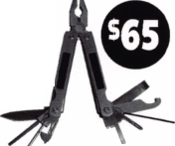

call me.

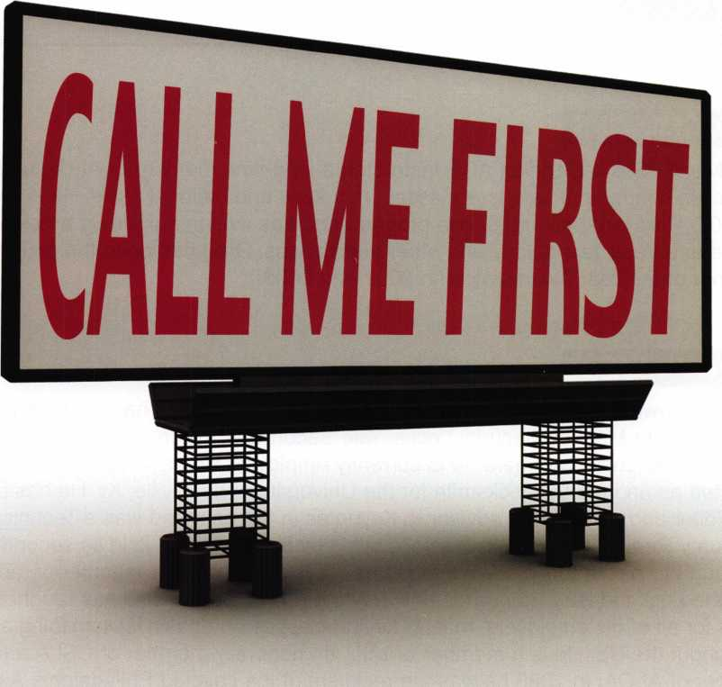

which one catches your attention?

Bigger is sometimes better. And when someone is in need of your services, you want to take every opportunity to make your name prominent in the minds of searching consumers.

Introducing a new advertising solution from ALOA. At our new public locksmith search site, findalocksmith.com, you can now purchase an ad for your business that will shine brightly on the results page whenever someone searches for a locksmith in your zip code. The initial cost is only $30.00, and each additional zip code you add is only $5 extra. Don't miss this great opportunity!

Call Kim Hammond at 817-645-6778 for details.

Spaces for each zip code are limited. Call to reserve yours now!

about the authors

**Greg Perry, CML, CPS**

Greg Perry, CML, CPS is a Certified ACE Instructor, a long-time member of ALOA and SAVTA and has taught access control and safe lock classes on a local and national basis. He is the author of the SafeData CD Rom database reference program and has written numerous articles for Keynotes, Safe and Vault Technology and other publications. Greg has been the recipient of Keynotes’ Author of the Year Award twice (in 2002 and 2003).

**Billy Edwards, CML**

Billy Edwards is known for his expertise in Master Keying. Mr. Edwards has held the position of Key Records Manager with Medeco Security Locks, Yale Security, ASSA Inc., Abloy Inc., Arrow Lock Company and Master Lock Co. where he is currently employed. He has been a locksmith since 1969 and started as an in-house locksmith for the University of Louisville, Ky. He has been a Contributing Editor and an Editorial advisor to Keynotes in the past and was a Technical Editor for the Reed Security Reporter. His book “Master Keying by the Numbers” is in its second printing and available through the ALOA Store at [www.aloa.org](http://www.aloa.org). He is also a charter member of, and current Chairman of, the Lock Industry Standards and Training (LIST) Council. He has taught factory certifi­cation classes for all of his employers, master keying classes and basic locksmithing and picking classes throughout the US. He is a member or IAIL, an honorary member of CSLA and MLANJ, a 30 year member of ALOA. In 1988 he was the recipient of the coveted Philadelphia Award.

**Dave Thielen**

David E. Thielen, CML is the lockshop manager for Adams Twelve Five Star School District, Broomfield, Colorado. David has been a professional locksmith for more than 25 years a member of RMLA and DHI and a member of ALOA since 1985. He has instructed classes for the Rocky Mountain Locksmiths Association and has developed and instructed ACE certified classes for ALOA at regional and national conventions. David is a two time winner of the ACE Instructor of the Year award, most recently receiving the 2004 ACE award which is presented to the outstanding ACE instructor for the year.



Keynotes • February 2005

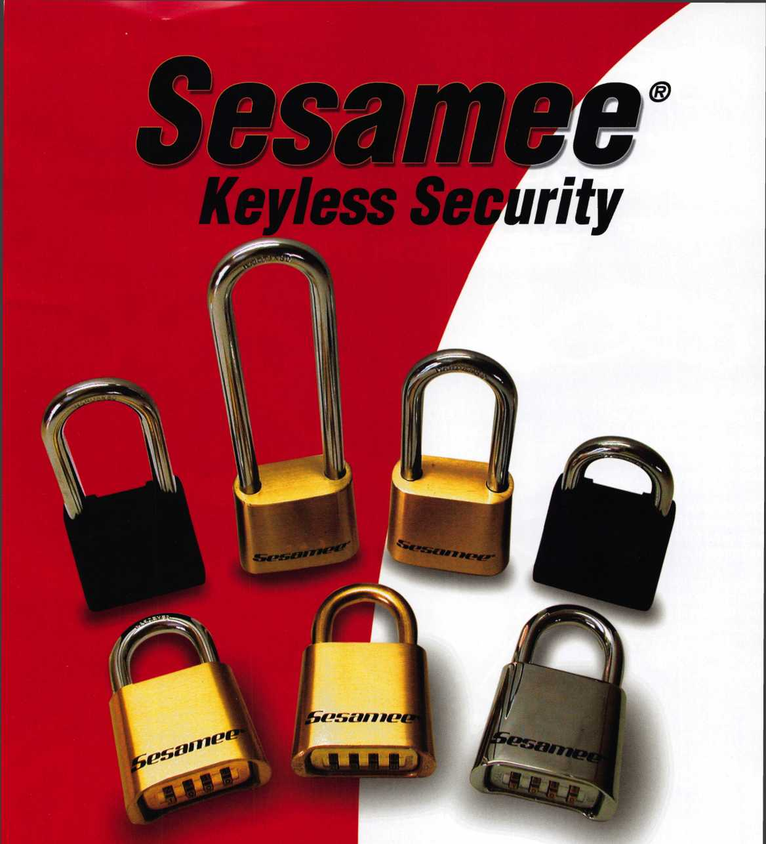

Security Products

**301 West Hintz Road Wheeling, IL 60090 Telephone: 800.733.8588 Fax: 847.537.1881 [www.cclsecurity.com](http://www.cclsecurity.com)**

* No Keys to Carry, Lose or Break
* Re-settable Combination
* Brass and Hardened Steel Shackles
* Ideal for Chain Link Fence and Gates
* Construction Job Sites and Gang Boxes
* Tool Cribs and Supply Areas
* Marine Use
* Oil, Gas and Pipeline Security



**New Generation STAR XL GAN Transponder Programmer**

'I've lost my Taurus keys...

:an you make me a new set?'

How much of your money  
have you sent to the  
local Ford Dealer?

NGSSTAR XL CAN Locksmith 8008LXLC

Did you Know...

...the Dealers charge an average of $100 per transponder key?

...you can get the factory transponder tool for less than the cost of doing one key per month?

CAN VIM

81201L

Use what the Dealers use for complete  
coverage on ALL Ford/Lincoln-Mercury and  
Mazda vehicles equipped with transponder  
keys. The NGS XL CAN offers complete  
transponder coverage including CAN protocol  
and the ability to clear ALL Diagnostic Service Codes.

ou re never on your own...  
oil Free Technical Support  
1-800-342-5080

**2004 Software Update and CAN Vehicli  
Interface Module now available.**

INCORPORATE

